Social Event #1 - Board Games
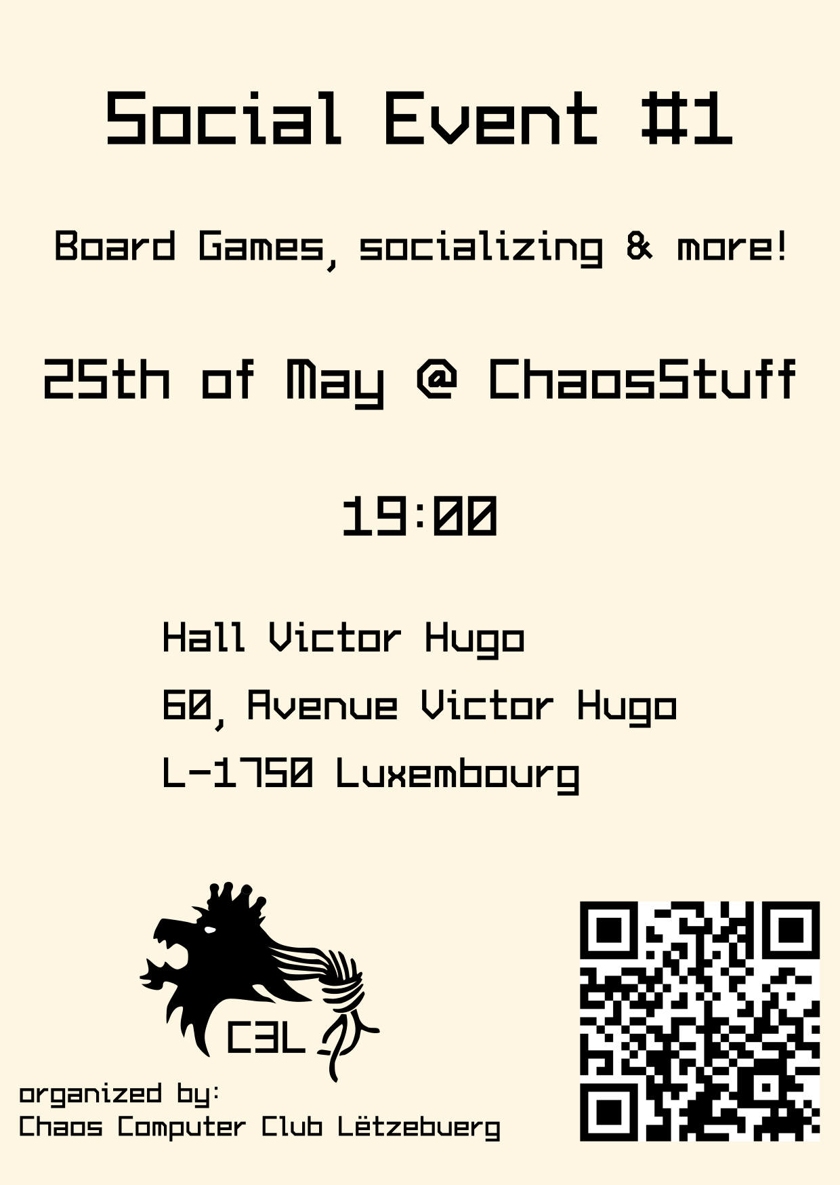
Date | 25/05/2019 - 19:00
Venue | ChaosStuff
Description | Board games, socializing & more!
Contact | metalgamer
Participants | Peter Alfons Loch, de_jose_wees_de_wee, orimpe, deflenken
Our second social event. Come and socialize with other like-minded people and play some board games.

Board Games
Board Game | User
Zombie Dice | metalgamer
Cards against humanity | Peter Alfons Loch
Star Wars Monopoly | orimpe
Imploding Kittens | orimpe
Wou läit Grandsen? | orimpe

