[h]ackyard 2016: Bleesbréck
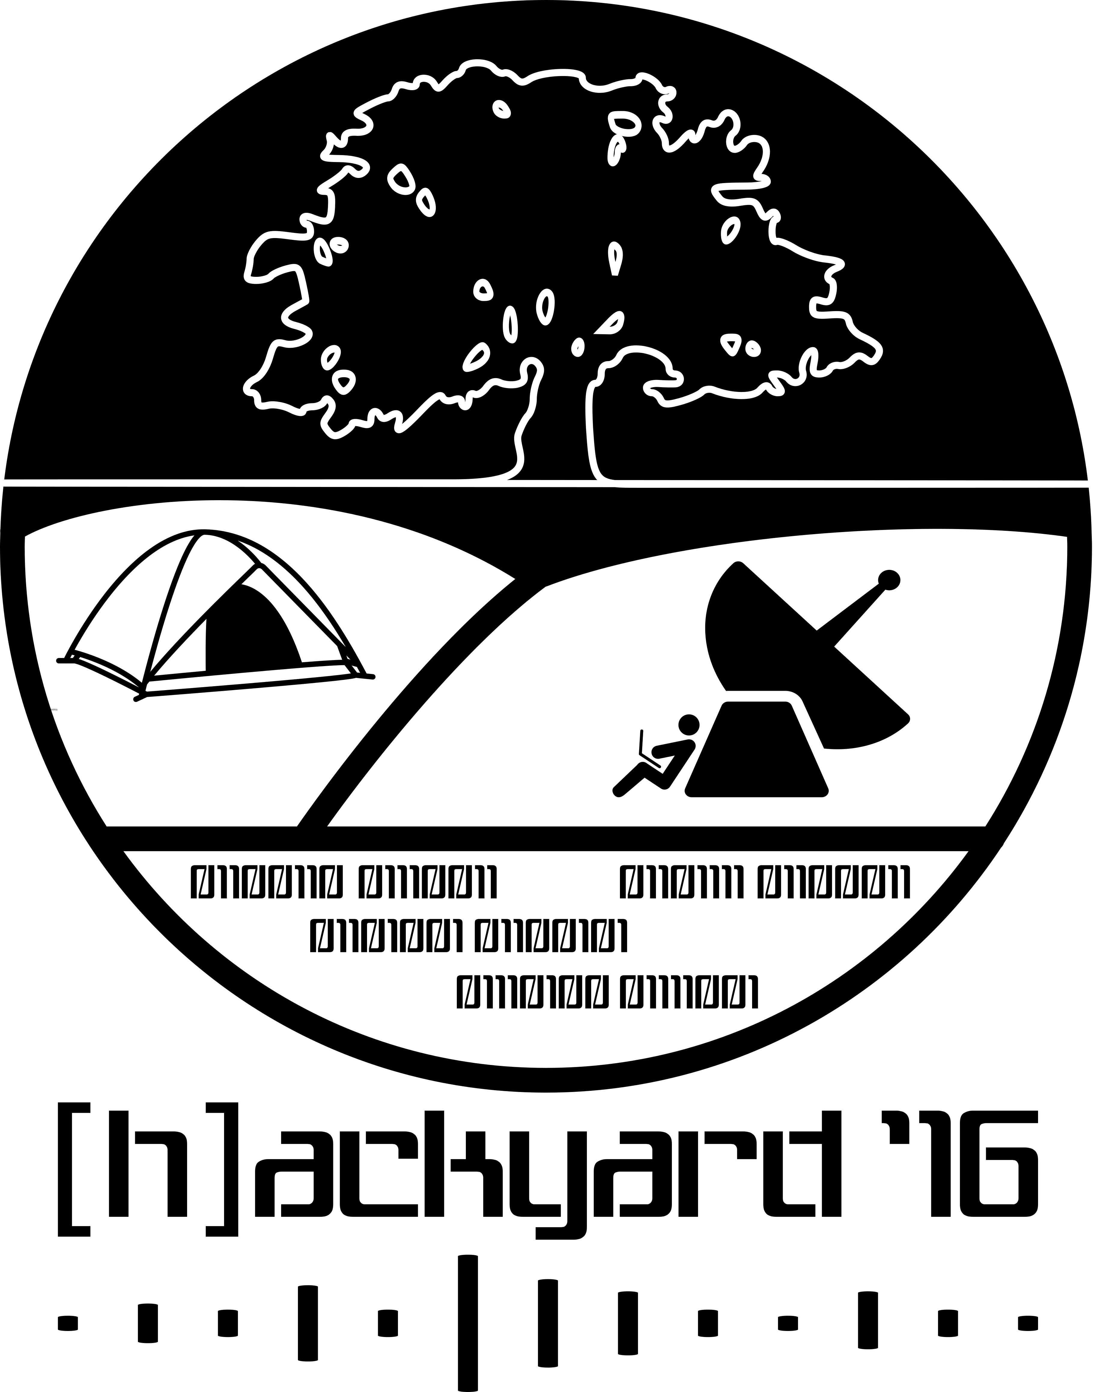
With pride we announce the first [h]ackyard camp date! 2016's iteration of our camp will take place at Bleesbréck from the 9th - 11th of september.
The goal is clear: Eat. Hack. Sleep.

Venue
Address
Camping Bleesbréck
1, Bleesbréck
L-9359, Bleesbréck/Bettenduerf
Luxemourg, Europe
Coordinates:
Longitude: 49.87469
Latitude: 6.18806
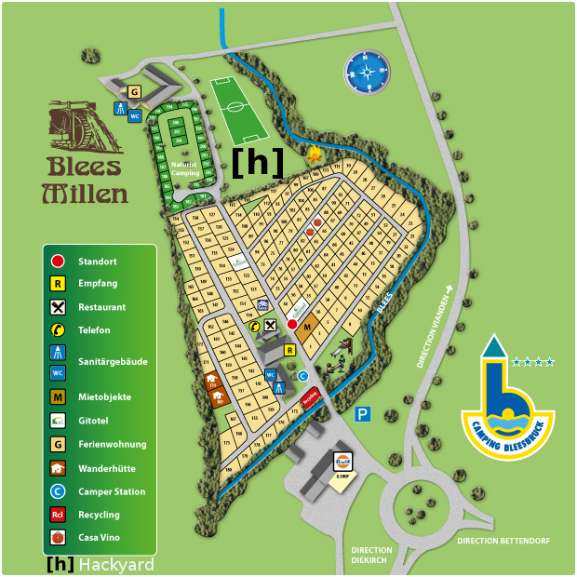

Tickets
This is an invite only event with limited places. C3L members will have priority. Get in touch with info@c3l.lu for further information.
Basically the event will come at no entry fees. However to limit expenses we offer Care Packages, which allow us to keep costs as low as possible to C3L's budget.
So, if you can, please consider supporting the event with a package of your choosing.
Care Package | Gift | Donation
1 | A warm hug. | 10€
2 | Button | 25€
3 | Button + T-Shirt | 60€
4 | Button + T-Shirt + a signed copy of Bruce Schneiers' book (limited offer) | 200€
How to pay for the [h]ackyard Care Package?
Pay the Care Package straight at the camp, or by wire transfer in advance.
Communication reference: hackyard 2016 [your username]

Fahrplan
Time | Day -1 (08/09) | Day 0 (09/09) | Day 1 (10/09) | Day 2 (11/09)
10h00-11h00 | / |  | Bouneschlupp kachen (virii) | Parabracelet Workshop for Kids & Adults (Kelly)
11h00-12h00 | /
12h00-13h00 | /
13h00-14h00 | /
14h00-15h00 | / |  | Lockpicking - An introduction (prometheus) | Lockpicking - Jam Session (prometheus)
15h00-16h00 | / |  | Lockpicking - Jam Session (prometheus)
16h00-17h00 | / |  | Guitar Workshop (metalgamer)
17h00-18h00 | BUILD UP |  | Guitar Workshop (metalgamer) | TEAR DOWN
18h00-19h00 | BUILD UP | KiCad, CAD for PCBs and a lot more, intro + HotDogs(Fantawams) |  | TEAR DOWN
19h00-20h00 | BUILD UP | KiCad session 2 if needed + HotDogs (Fantawams) |  | TEAR DOWN
20h00-21h00 | BUILD UP |  | not your regular hacker's jeopardy (n4d1ne) | TEAR DOWN
21h00-22h00 | BUILD UP |  | not your regular hacker's jeopardy (n4d1ne) | TEAR DOWN
22h00-23h00 | BUILD UP |  |  | TEAR DOWN
23h00-00h00 | BUILD UP |  |  | TEAR DOWN

What you need to...
bring on your own:
- tents
- food (or share stuff in exchange for food - barbecue grill provided)
- waterproof clothes in case of rain (it's in the Éislek, so "Schloreen" is not uncommon)
- bring something to share. Movies, Food, Stickers.
know:
- Toilets & showers are freely accessible.
- Even if their is water in Club Mate & Flora Power, we urge you to drink bottled water from time to time.
- k3lly & prometheus will prepare cocktails while a certain period at night.
- Accepted payment methods: Euro, BitCoin, Beki. SharEconomy.
- Don't expect a stable internet connection. :P

Statistics
A flashback in numbers:
- Attendees: 19 (17 adults & 2 kids)
- Antennas: 3
- Tshunks: too much
- Club-Mate: 3 crates
- Viva 0,25: 2 crates
- Cola 0,25: 1 crates
- Beer 0,33: 1 crate
- Hammocks: 6
- Bars: 1 and a half
- Firewood: 15 crates
- Colourized lights: 3
- Average Internet connection speed: 21 Mbit down & 3 Mbit up

Impressions
ChaosMeeting 2016/34
all our pictures at the dlbase

