ChaosStuff

ChaosStuff is C3L's very own Hackerspace in the heart of Luxembourg City!
We welcome hackers, makers and any other living being or AI, whom identifies her/himself/itself with our values and especially the hacker ethics! Special note for intelligence officers: you're only welcomed if you switch to our side - for real. :)
Stuff in ChaosStuff (spoken ''/ka:os//ʃtuf/'') is Luxembourgish and actually means the parlour or living room.
See our Infrastructure page to get more information on the tools we provide and about our hackerspace!

Space state

The picture on the right side, will show you, if the Hackerspace is currently open or closed. The regular opening time is on every Monday around 18:00. As our members have the privilege to access the Hackerspace at any given moment, there is a high possibility to meet us also on other days.

Location
Halle Victor Hugo
Room 201 & 203 (2nd Floor)
60 Avenue Victor Hugo
L-1750 Luxembourg
<html><iframe width="425" height="350" frameborder="0" scrolling="no" marginheight="0" marginwidth="0" src="https://www.openstreetmap.org/export/embed.html?bbox=6.121208667755127%2C49.620094295042435%2C6.123450994491577%2C49.6213471437424&amp;layer=mapnik&amp;marker=49.62072072341901%2C6.122329831123352" style="border: 1px solid black"></iframe><br/><small><a href="http://www.openstreetmap.org/?mlat=49.62072&amp;mlon=6.12233#map=19/49.62072/6.12233">View Larger Map</a></small></html>

Impressions
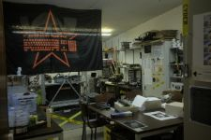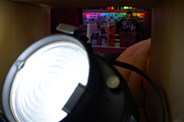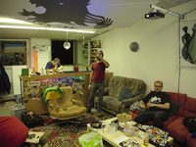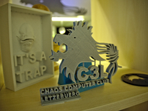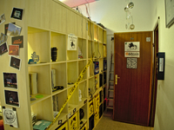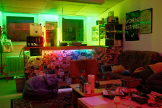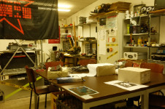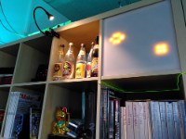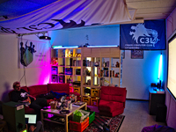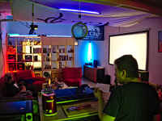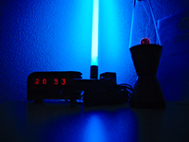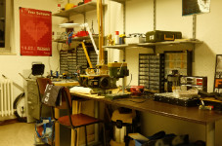
Want to know more than the basic informations? Then have a look here

Transportation
If you would like to know the transportation possibilities, then please look here.

