This page is not fully translated, yet. Please help completing the translation.
(remove this paragraph once the translation is finished)

Projects
Projects are a vital part of an association's life. Hackers have lots of ideas, but time is not an infinite resource. So, think wisely about what ideas you would like to realize and try to inspire some other fellow members putting them to life.
On the other hand, we'll be straight forward with you, are the financial resources. These aren't for most NGOs infinite too. So, if you have the possibility to donate to your favourite project or just to all of them, please consider doing so.

Highlights
entr0py Encore
Freifunk
SETI Box
Command & Control
Freifunk
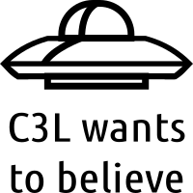SETI Box
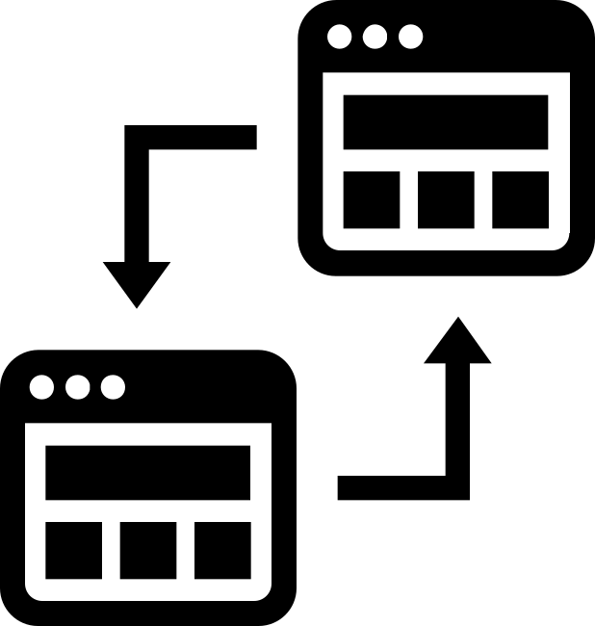Command & Control

Hardware
Tor Hotspot
Tor Hotspot
Molecular Construction Device aka. 3D Printing
|Molecular Construction Device aka. UltiMaker (mcd)
Weather station
Weather Station
Lockpicking
Lockpicking
Smarter Traffic Light
Traffic Light
Skynetbot aka. self learning robot
Skynet SCP Logo
PSU Hacking
PSU Hacking
Jabel
Jabel
Facuum
Facuum

Decoration
Game of Life
Game of Life
MQTT Lights
MQTT Lights

Food & Inventory & Stuff
Foodhacking
Foodhacking
Hydroponic
Hydroponic
poteen
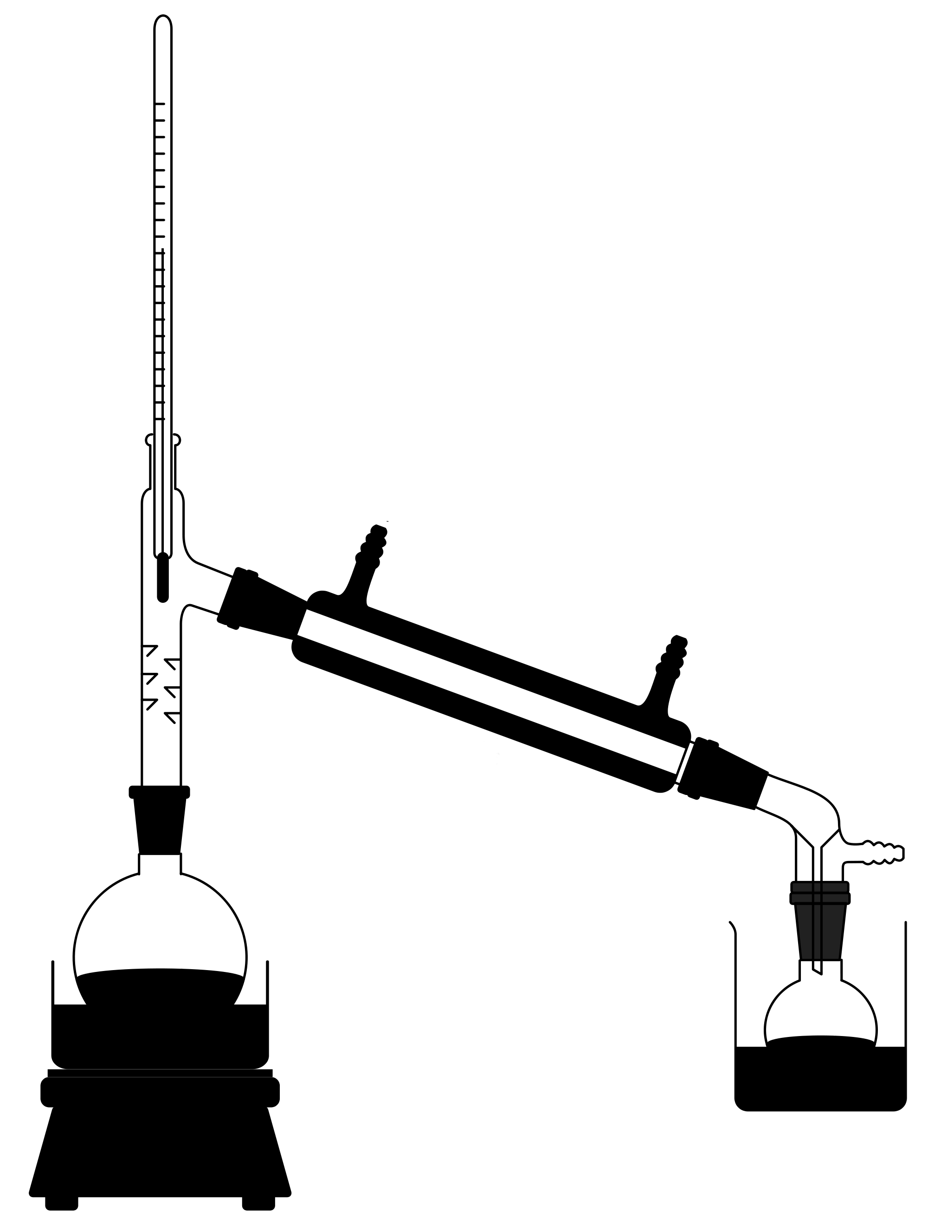poteen
Retro gaming
Retro gaming
YaB
YaB - Yet another Bar

Community
Cypherpunk
Cypherpunk
Photo Nerds
entr0py Encore

Repair Café

Education
Encryptia

Wearables
Neopixel Goggles
Neopixel Respirator

Misc
- Besides project documentations, we also provide HowTo's to elaborate specific steps.
- The only barrier is your imagination. Scribble down the blueprints in the pool of ideas, before you forget about them.
- Concluded or suspended projects find their new permanent or temporary resting place in the Archives.
New Project
Create a new project by simply using the form above. It loads a template with predefined values for you to complete. By this process we can assure, that all newly created project pages, kick-off with the essential metadata we'd like to store.

