FOSDEM 2015

Finally, we have made it again. FOSDEM conference has started yesterday evening in Delirium bar with the traditional beer event. Lots of brewed beverages to choose from and above everything else, a lovely and heartwarming community to talk wiwikth.
However, the 'real thing' is always to start on Saturday morning with the first keynote. I guess, it is not necessary for me to point out, the motivation of attendees, pictured on the right.
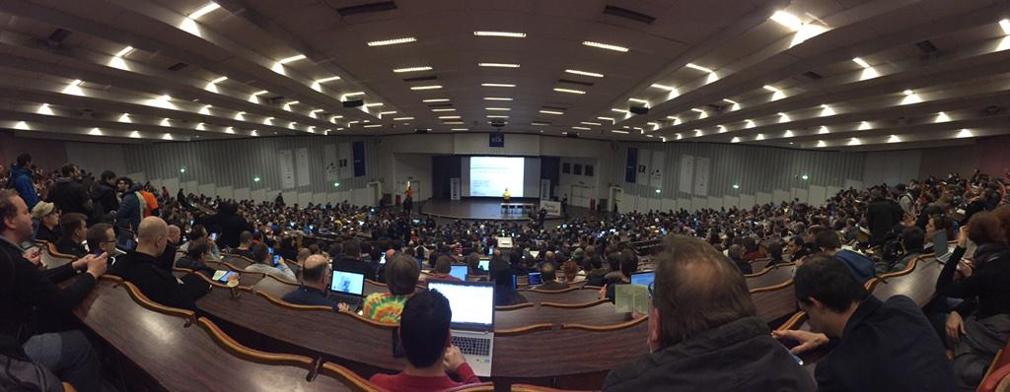
As the conference has just kicked-off, there is not much to report just yet, but I will keep you up2date throughout the day in this very blog post.
Stay tuned via @c3l on Twitter! Or gold old RSS. ;)
Update
You can find impressions about FOSDEM 2015 here.

