Grafana (LAN)
Hostname: roonadan.lan
IP address: 192.168.1.189

Dashboards

Turris (mcr-alpha)
- http://roonadan.lan/d/1i0gquEmz/turris?orgId=1&refresh=30s
- http://192.168.1.189/d/1i0gquEmz/turris?orgId=1&refresh=30s
- 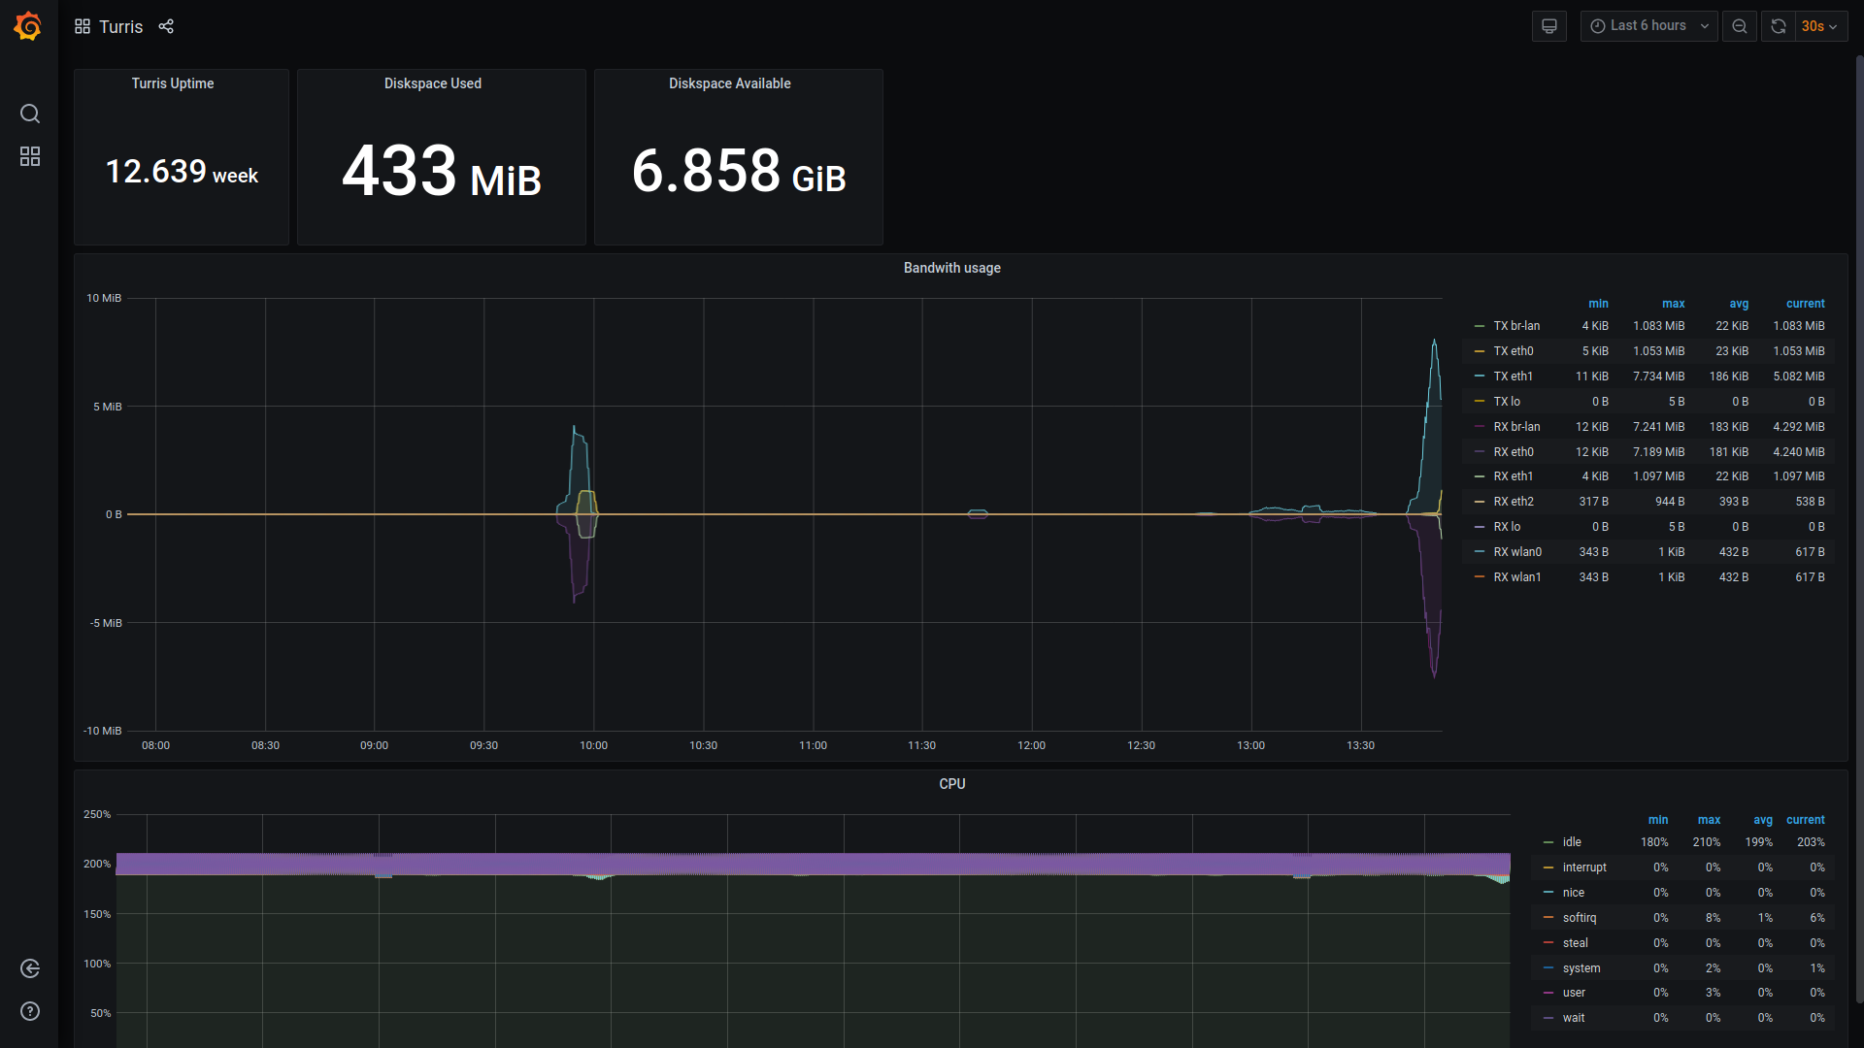

MQTT (mcr-gamma)
- http://roonadan.lan/d/hfvfaCyik/mqtt?orgId=1&refresh=30s
- http://192.168.1.189/d/hfvfaCyik/mqtt?orgId=1&refresh=30s
- 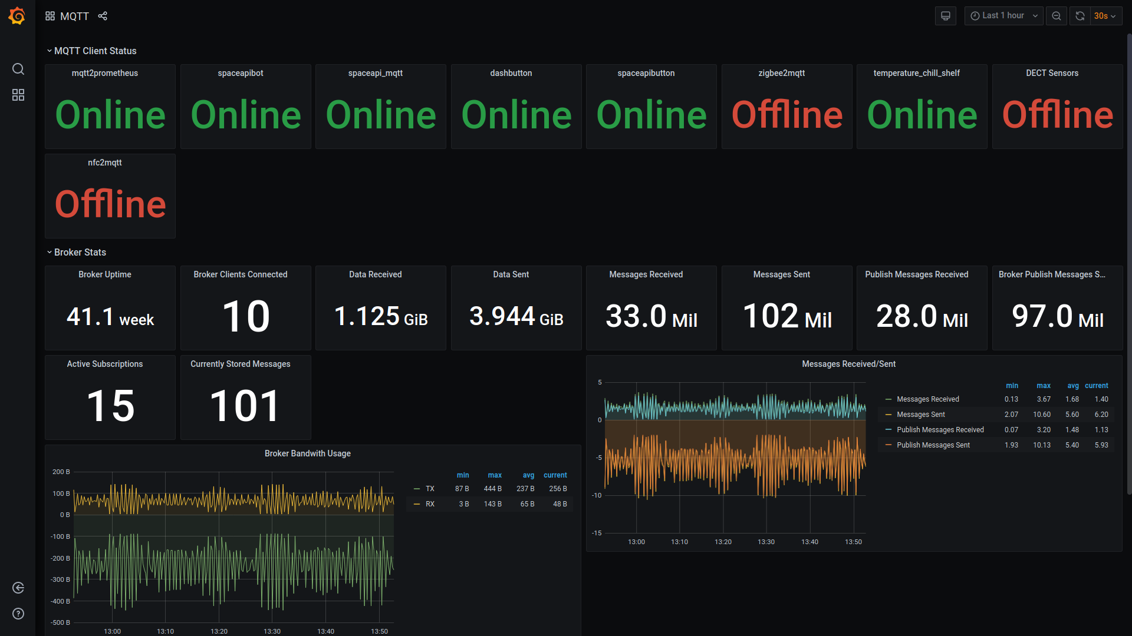

ODroid (mcr-delta)
- http://roonadan.lan/d/tI2qaTEiz/odroid?orgId=1&refresh=30s
- http://192.168.1.189/d/tI2qaTEiz/odroid?orgId=1&refresh=30s
- 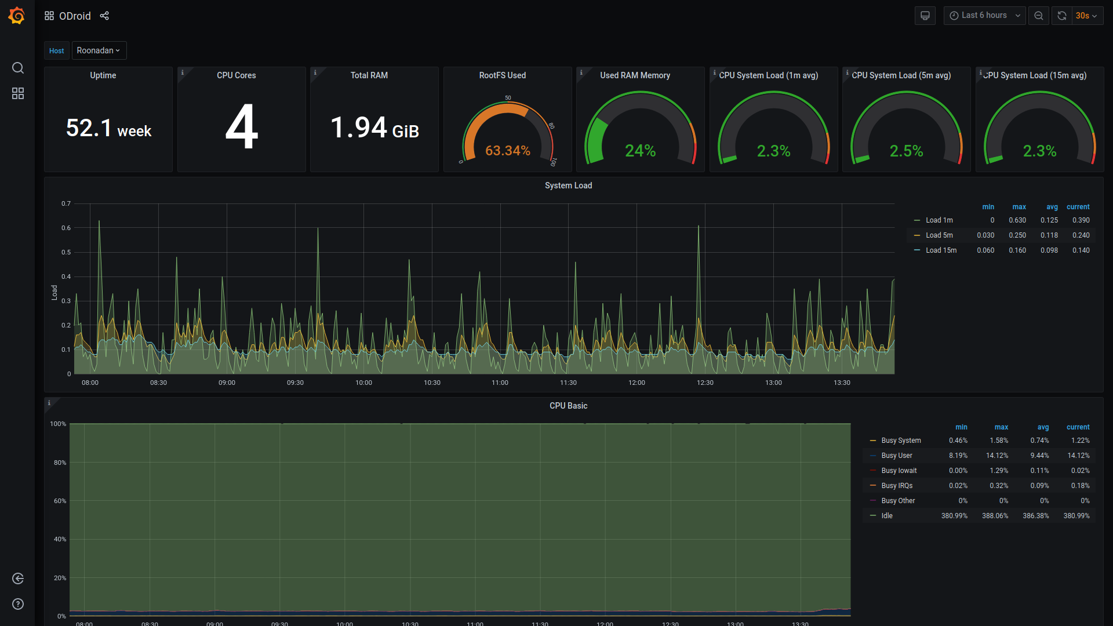

SpaceAPI (mcr-beta)
- http://roonadan.lan/d/OsA71lsiz/spaceapi?orgId=1&refresh=30s
- http://192.168.1.189/d/OsA71lsiz/spaceapi?orgId=1&refresh=30s
- 

