Soldering Area
Mentors | metalgamer & peter
Admission | Admission List
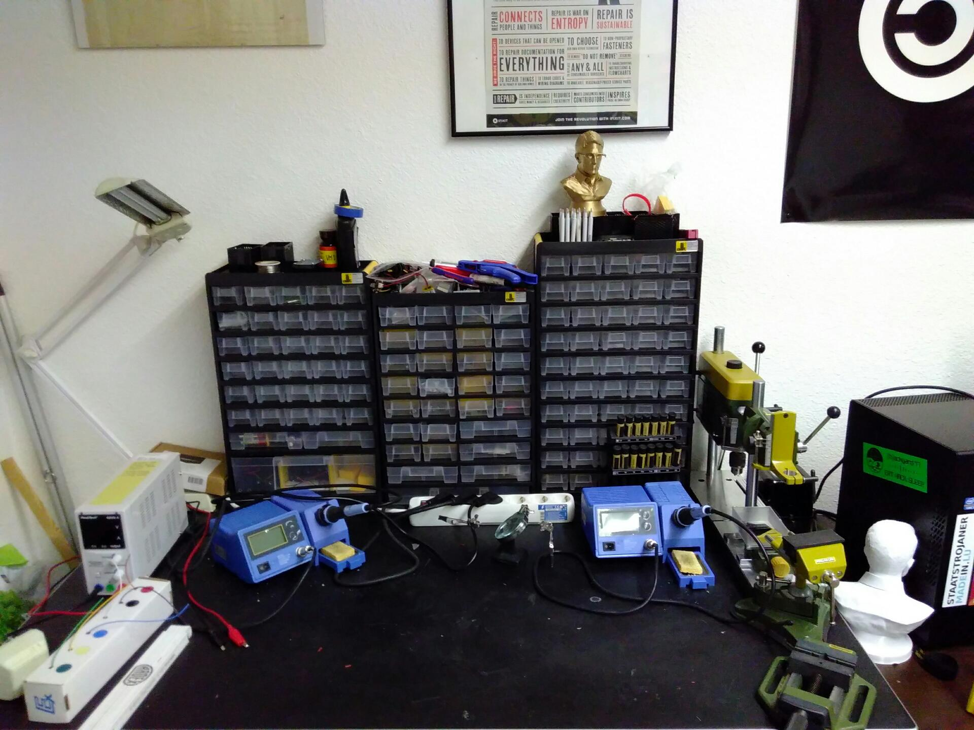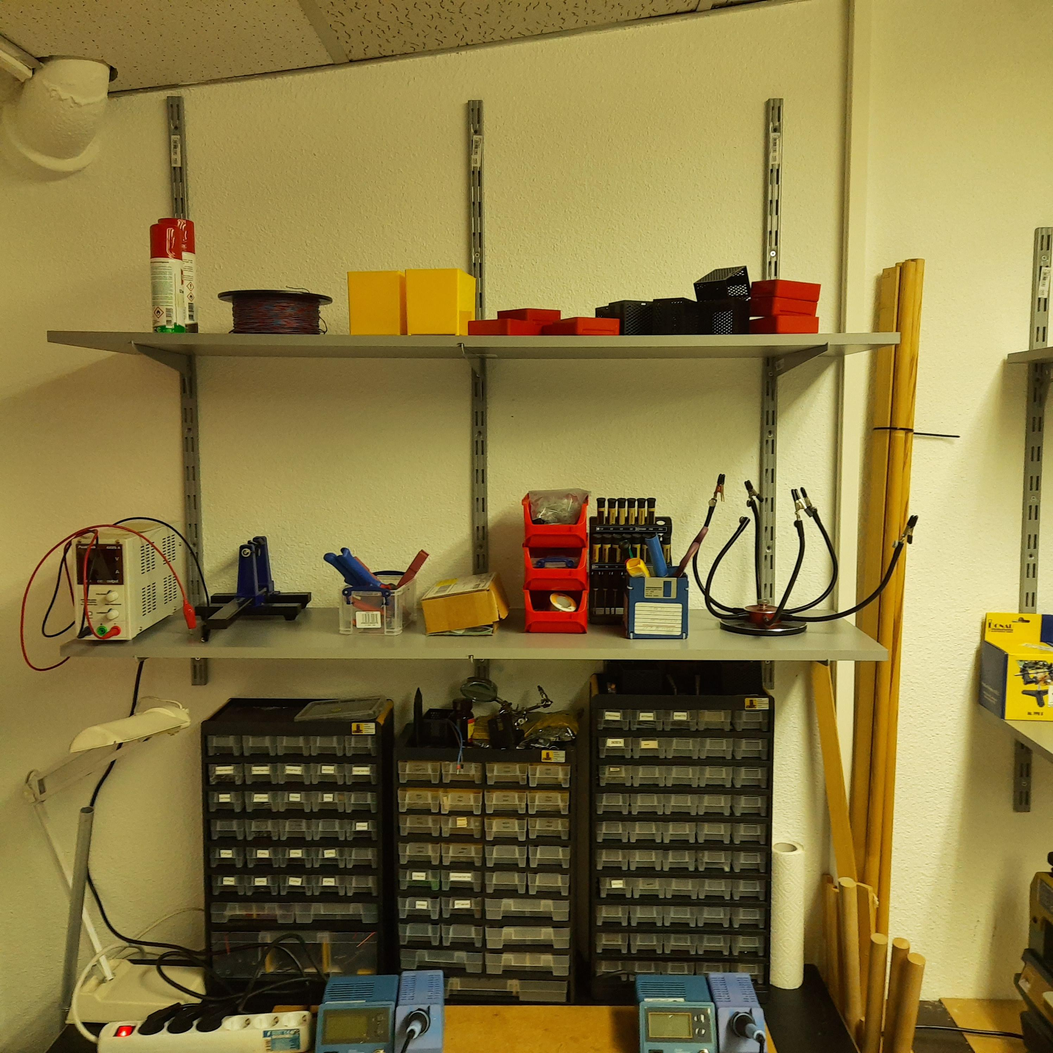
QRCODE>https://wiki.c3l.lu/doku.php Link to this page
The soldering area is located in the lab. Equipment and parts can be used freely after you have been instructed by one of the mentors.
Safety first. If you are unsure or have no knowledge on how to use the equipment you want to use, ask other members to help you out. Always keep the needed safety rules in mind. If safety gear for a device is required but is not available, then the specific equipment should not be used. Also contact as soon as possible, one of the above listed mentors.Clean after yourself. If you are done using it please clean the table and put everything back where it belongs. This is for the safety of the cleaning staff and other members.The equipment is expensive, take care of it like it was your own. Usual rule: "You break it, you fix it"

Equipment
Equipment connected to the switchable power strip:
- Two soldering stations (ZD-931)
- PeakTech 6225 A (DC lab power supply)
Turn on the power strip to use this equipment, and turn it off when not needed or leaving the space. The power strip assures that the equipment won't be accidentally switched on by the cleaning staff or other members. The main power strip is controlled via a network attached socket, so please make sure, that you have opened the space via the SpaceAPIBattery powered equipement:
- Multimeter
Non-powered Equipment:
- Desoldering pump
- Pistol wire stripper
- Small wire cutter
- Bending Tool
Special equipement:
- Oscilloscope
- Etching machine
- ReflowR (SMT Soldering workstation
Special equipment usually needs an introduction for safe usage. Contact the specific member who is mentioned at the usage explanation of the device.

Components storage
We have 3 components storage boxes. You can use the components for your projects.
The left-most storage box contains connectors. Here you can find pin headers, sockets etc…. The middle one contains basic electronic components. Here you can find resistors, capacitors, diodes etc…. The right-most one containcs ICs. Here you can find sensors, Arduino-like boards, logic-level shifters, shift registers etc….
Sometimes we have a shortage of specific parts, they are not expensive and have to be usually ordered in bulk. If you have more parts than needed you can put them in the parts shelf at the back of the table. This is always appreciated.

How to use the equipment

Soldering stations (ZD-931)
QRCODE>https://wiki.c3l.lu/doku.php Link to this section
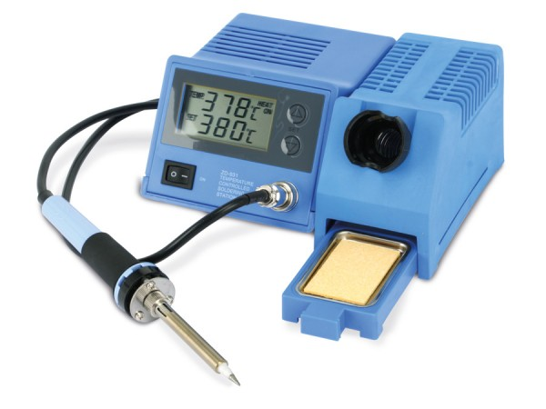
Do not use the soldering stations if the leads or other parts of the device are visually broken or damaged.To use the soldering stations, you need to turn it on with the switch on the front left of the device.
The soldering irons get very hot, do not touch the non-protected parts of the iron. Touching the non-protected parts of the soldering iron can result in 2nd to 3rd degree burns. If you need to change the tip, check if the iron has cooled down, by using the IR-temperature measurement pistol (safest) or by shortly putting it on the damp sponge (not safe). If you have swapped the tip, please, after use, let it cool down and put the original tip back. (fine tip on the left station, small chiseled tip on the right station)How to use the soldering stations:
- wet the sponge, below the soldering iron. (damp, not dripping!)
- turn on the soldering station with the switch on the front left of the device
- set the needed target temperature in °C (bottom number) (check the solder you use, if you are using the provided solder 320°C-340°C is sufficent)
- wait for it to reach the target temperature (top number)(+/- 2°C)
- put a little bit of solder on the tip of the soldering iron, then clean it on the sponge
- touch the copper part of the pcb and the metal part of the part you want to solder, while holding it touch the tip with the solder wire (the solder should flow into position)
- pull away the solder wire before pulling away the soldering iron
How to turn off the soldering stations:
- clean the tip of the soldering iron by using the sponge
- put the soldering iron into it's holder
- turn off the device by using the switch on the font left of the device
The left station has a fine tip, while the right one has a small chiseled tip. Secure your PCB or parts by using the crocodile clamps or with the vice. If one or both soldering stations are broken or damaged, contact the SpaCo.Always switch off the stations that are not in useIf you don't know how to solder ask another member to show you or read this comic (also recommended if you already know how to solder)

ReflowR
Do not use the soldering stations if the leads or other parts of the device are visually broken or damaged.The surface plate gets very hot, do not touch the non-protected parts of the iron. Touching the non-protected parts of the soldering iron can result in 2nd to 3rd degree burns.The ReflowR has not yet been tested, be aware that the circuit breaker of the building might interruptMore information can be found here

Helping Hands
QRCODE>https://wiki.c3l.lu/doku.php Link to this section
Do not use the helping hands if the parts of the device are visually broken or damaged. Please contact the SpaCo.We have different helpings hands. Please take care when using them.
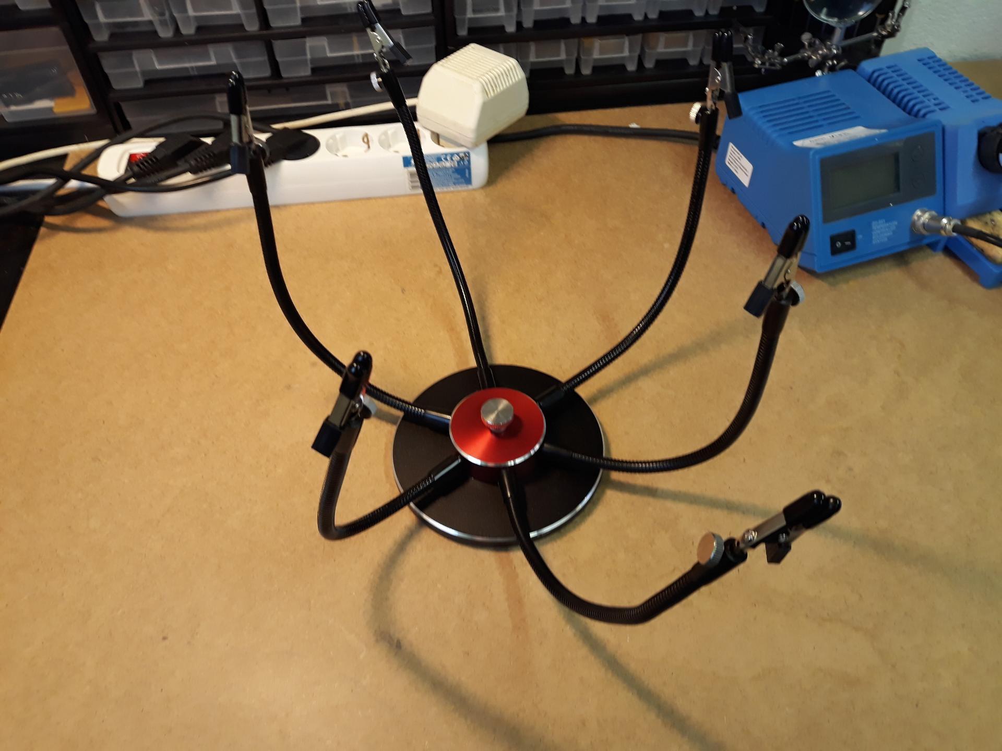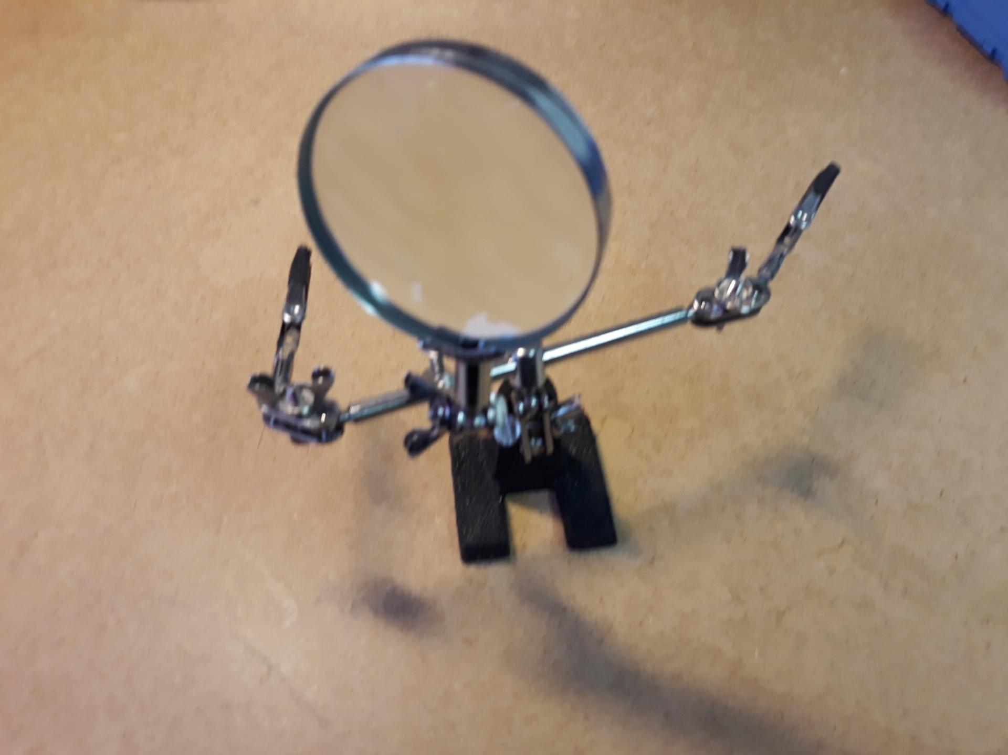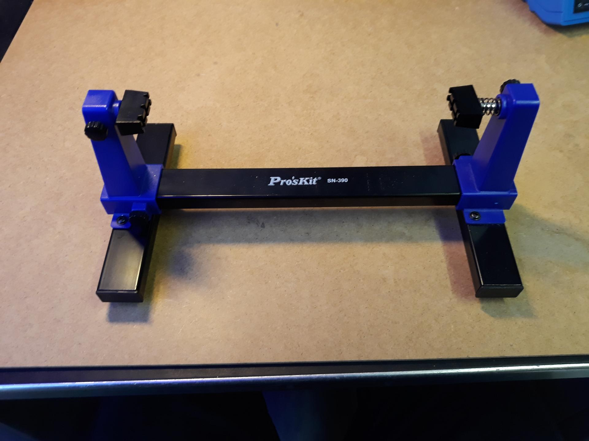

PeakTech 6225 A (DC lab power supply)
QRCODE>https://wiki.c3l.lu/doku.php Link to this section
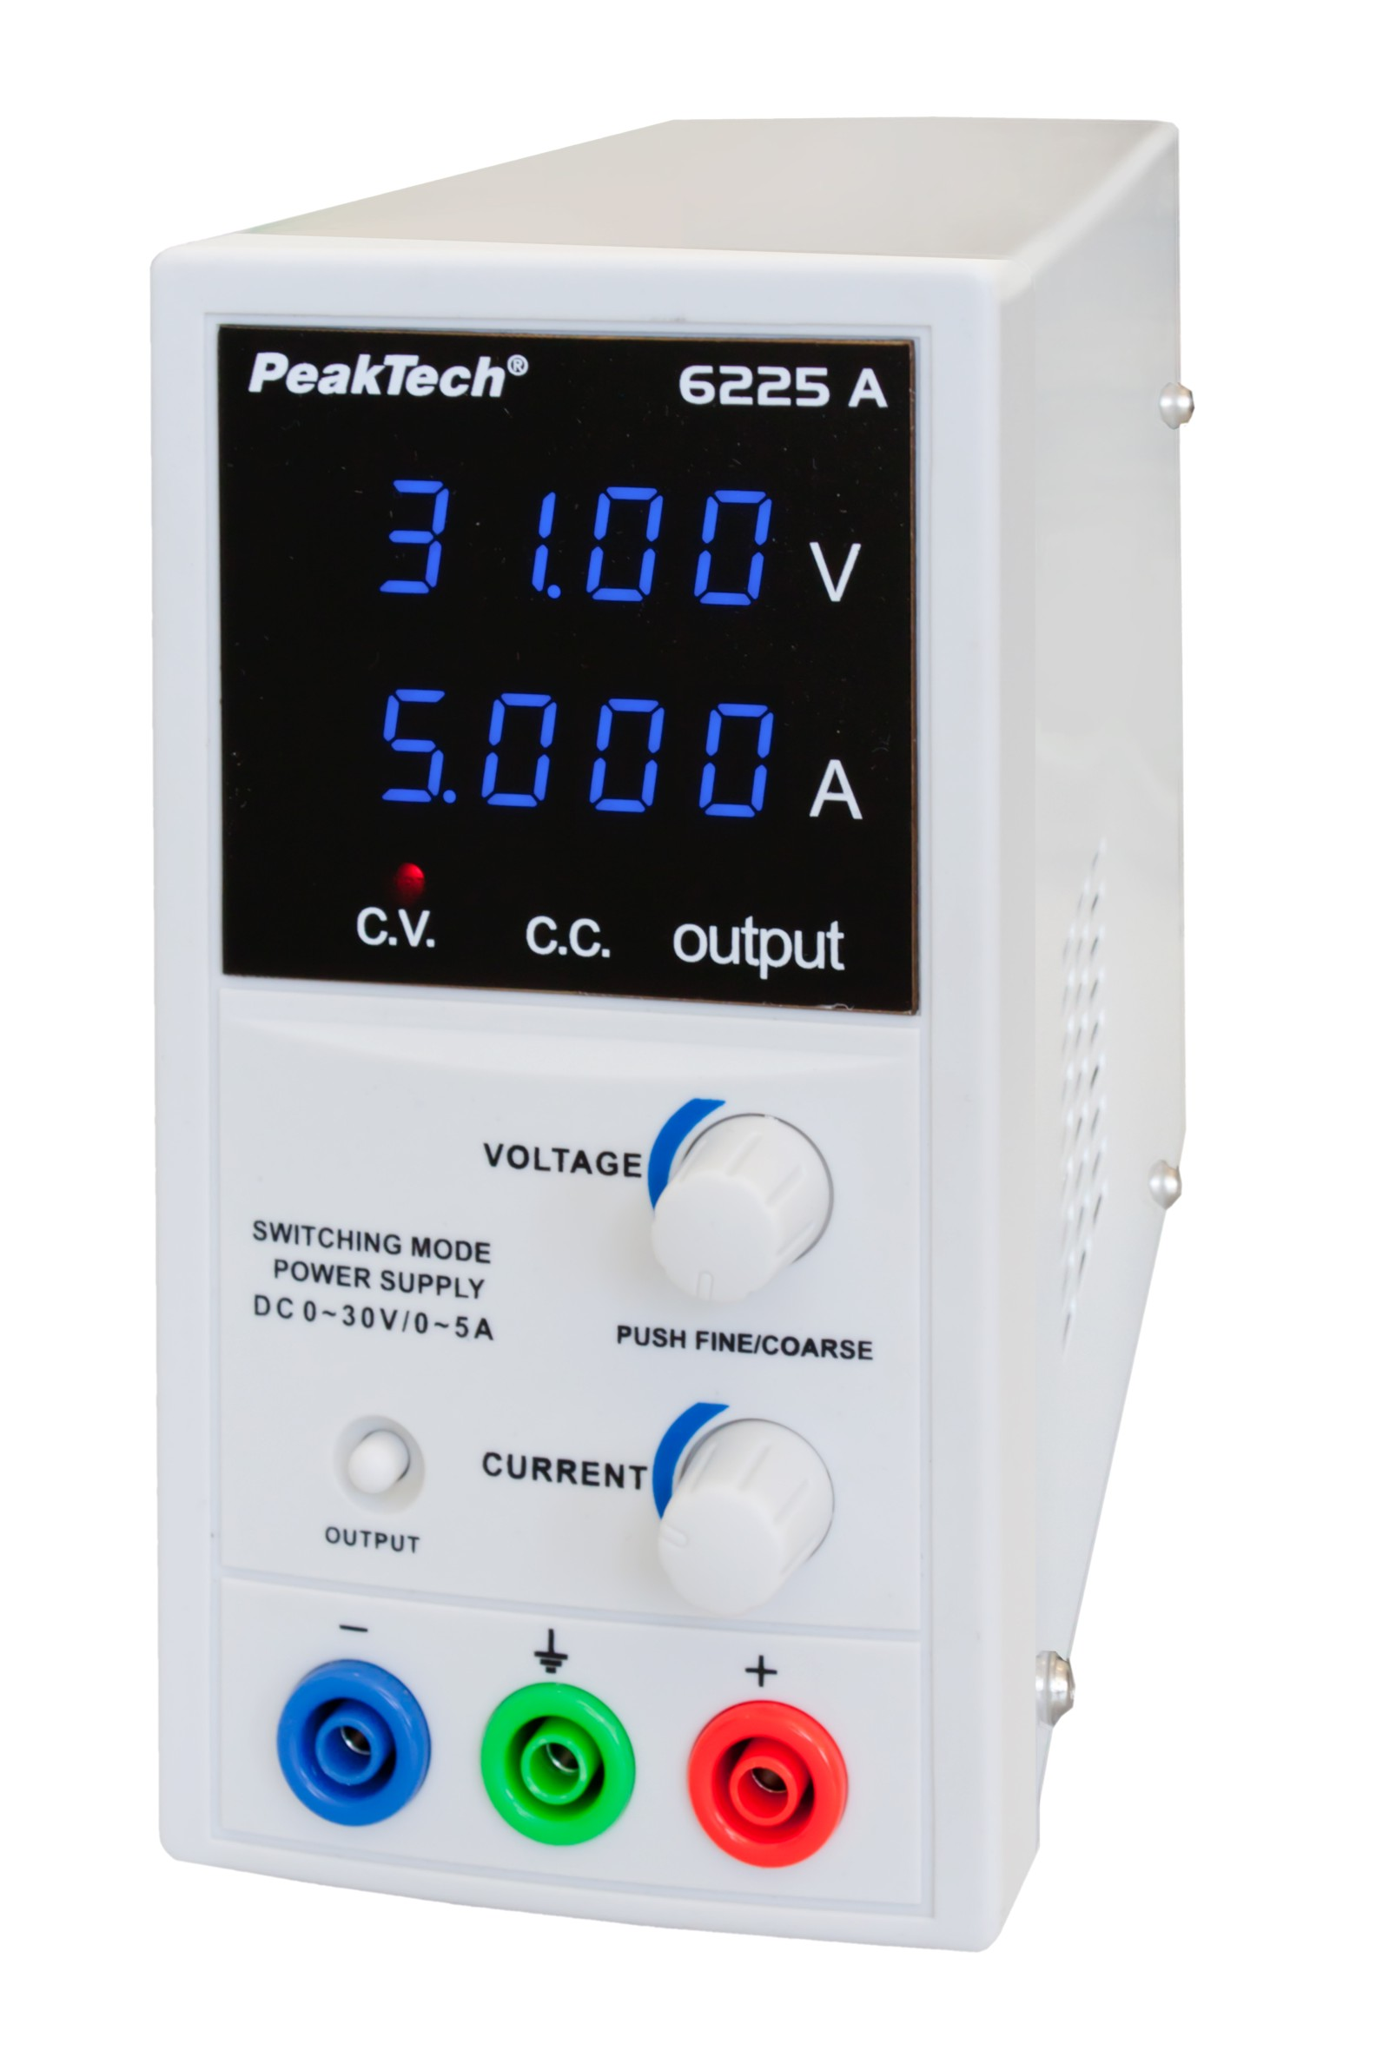
Before using the lab power supply verify that nothing is connected to it and that the leads are not touching themselves or anything else. Do not touch the lead ends.To use this lab power supply, you first have to turn it on on the back. Verify that the voltage and amperage are set to 0. The black lead goes to the blue connector on the left for the negative polarity, the red lead goes into the red connector on the right for the positive polarity.
Verify that the device you want to hook up is not powered seperately! The green connector is directly connected to the ground on the lab power supplys plug. Only use it for grounding if necessary, as wrong usage could flip the breaker. Do not short the connection, this could break the internal breaker of the lab power supply, and is very dangerous and might result in 3rd degree burns.How to use the lab power supply:
- turn on the device with the switch on the back of the device
- set the voltage you need between 0V and 30V
- set the maximum amperage you need between 0A and 5A (keep in mind that some devices can pull more than they can handle)
- connect the device you want to power
- click the small button labeled output to activate the output
- to change the voltage or amperage, it is best practice to first deactivate the output by clicking on the output button again
After having used the lab power supply:
- check that the output has been deactivated
- set voltage and amperage to 0
- power the device off with the switch on the back of the device
Always set the voltage and amperage to 0 when having finished your tests. Do not overload or intentionally break components/devices, using this lab power supply. Do not try to test the limits of the lab power supply or break the lab power supply intentionally. If the lab power supply is broken, contact Peter. Do not attempt to repair, modify or open the device without consent from Peter! Repairs/replacement parts have to be paid by the one who broke it.Tips:
- clicking the knobs will change the position of the "cursor" for voltage it will switch between 1V and 10mV and for amperage between 100mA and 1mA
- to activate keylock press and hold both knobs until the screen flashes once, to deactive do the same
- C.V. = Constant Voltage
- C.C. = Constant Current (this lights up when the current draw is at the maximum/set amperage)
- the lab power supply will not output more current than set
For more information consult the manual or contact PeterManual

Multimeter
QRCODE>https://wiki.c3l.lu/doku.php Link to this sections
Always use the correct setting. For measuring resistance, continuity or diode drop, make sure the part is not powered. If only type but not the max possible value is known, use the highest setting of the type you are measuring. (Lower it if the value is too small.) Do not connect the leads to the wrong plug, this could short the multimeter, break the part you are measuring or even result in 2nd to 3rd degree burns.Turn on the device with the red button on the left, connect the leads to their corresponding plugs on the device. Black lead usually goes to COM.
Voltage, resistance, diode drop, capacitance and continuity have to be measured in parallel, while amperage has to be measured in series. Capacitors should be discharged before measuring capacitance as it could result in a short or discharge the capacitor too quickly. Also check polarity before measuring.If you measure voltage or resistance, polarity can be swapped (but shouldn't for voltage). If the polarity is swapped for voltage, then the multimeter shows a negative value. Never swap polarity for measuring amperage. A diode only let's the current flow in one direction so try swapping the polarity if the diode drop is out of range.How to use the multimeter:
Will be written!How to store the multimeter:
Will be written!If the multimeter is broken or damaged contact SpaCo.

Desoldering pump
QRCODE>https://wiki.c3l.lu/doku.php Link to this section
Do not use if visually broken or damaged.Push the plunger down and press the button to release and activate the pumping mechanism.
If the pump does not "suck" it needs to be cleaned.How to use the desoldering pump:
- push the plunger down until it makes a clicking noise (it must remain in that position by itself)
- heat up the solder you want to remove
- hold the pump very close to the solder, but try to avoid touching the soldering iron (short touches are not an issue, yet best practice is to avoid it)
- press the black button to activate the pump mechanism
- remove the pump and soldering iron
- hold the pump above the soldering table (which you have to clean) or above the trashcan and push the plunger until it clicks and push it about 3-4 more times to release majority of stuck solder
How to store the desoldering pump properly:
- the plunger should not be pushed
- press the button to make sure that the internal spring is not under pressure
- put it back where you took it from
How to clean the desoldering pump:
- make sure that the plunger is not pushed
- press the button to make sure that the internal spring is not under pressure
- unscrew the tip
- slowly take out the components and remember the order
- with a dry paper towel clean the spring, the cylinder, the sealing rings, the thread and the metal rod
- use a screwdriver with a dry paper towel on its tip to clean the non reachable parts and the inside of the tip
- put everything back in reverse order you dismantled it
- try it out a few times to make sure you put it back together correctly.
Make sure the tip is screwed in correctly and that the threads don't misalign. If the pump is broken or damaged, contact the SpaCo.Do not leave the pump with the plunger being pressed. Do not use it to "suck" anything else than molten solder and do not use in water or make it wet.

Pistol wire stripper
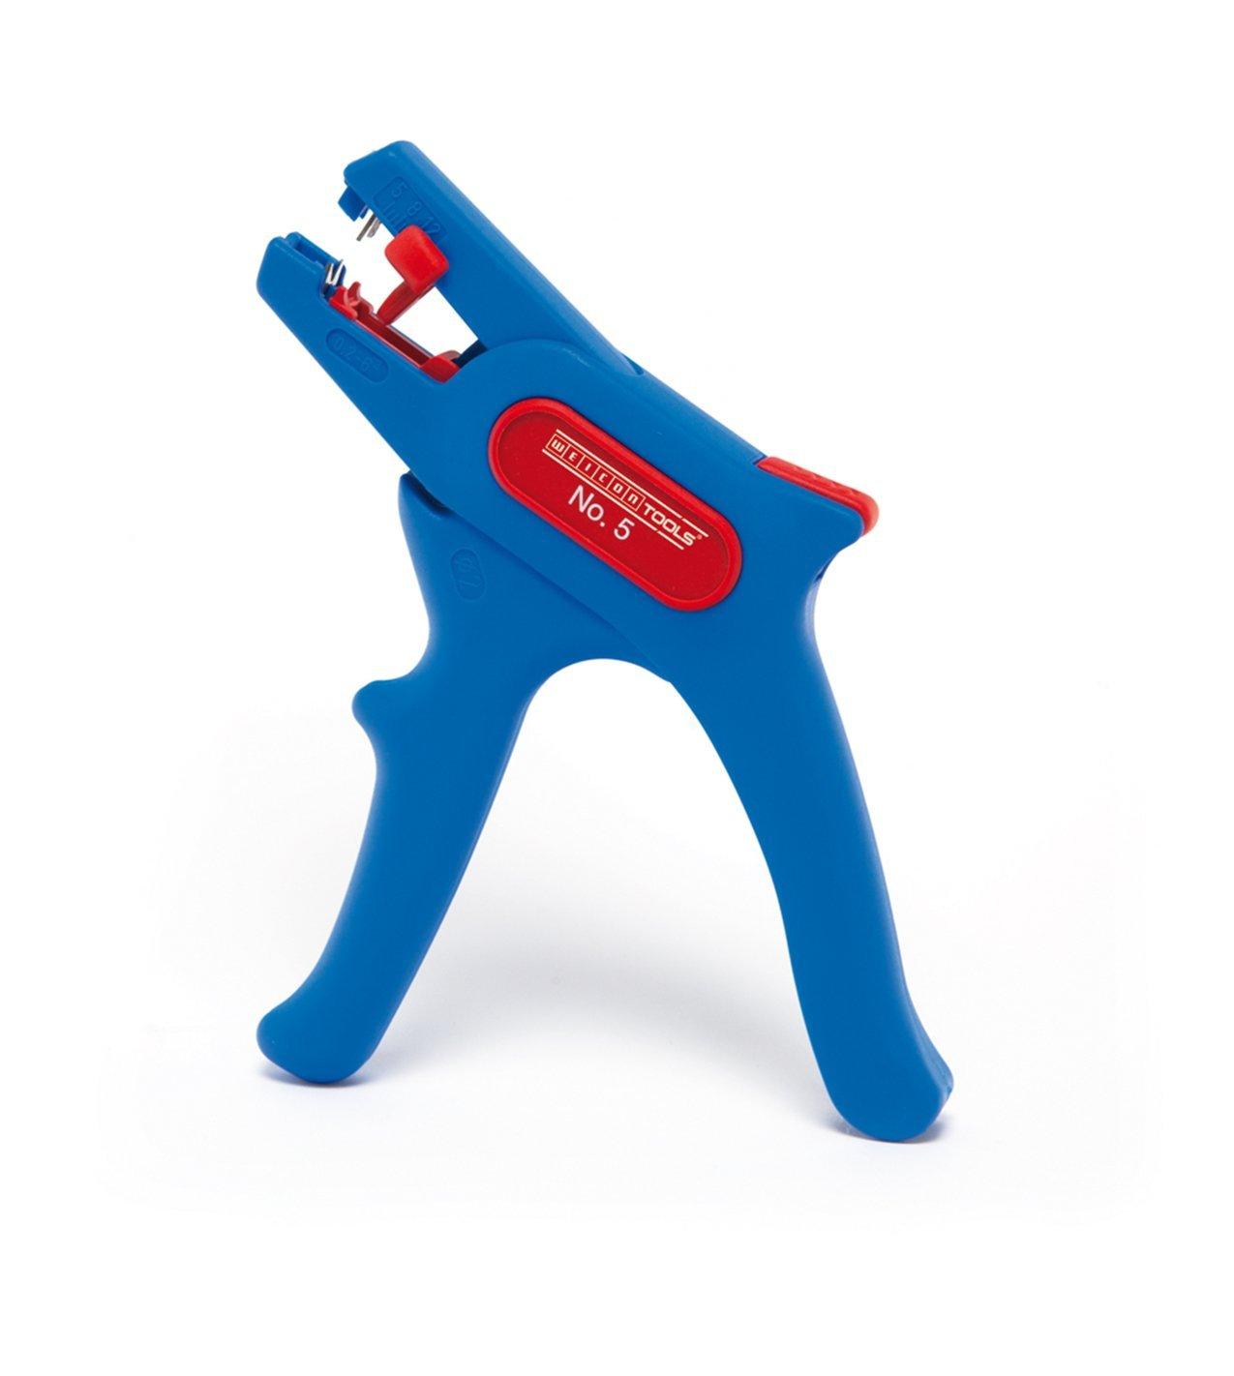
This tool has very sharp edges, you must NOT touch the metal parts or insert anything else than a wire into the tool!The pistol wire stripper has a locking mechanism which is the red piece on top of the tool, to use it you must first unlock it and when done it must be closed and locked to be safe for handling.
How to use the pistol wire stripper:
- Move the red slider on the front to the length you want to strip according to the provided scale
- Put the wire in the front of the tool between the sharp metal pieces until it touched the back-wall of the red slider
- Pull the trigger fast to nudify the wire
- Let go of the trigger and remove the wire
- If the isolation was only partially removed, then pull it off by hand

Small wire cutter
Will be written!

Bending Tool
QRCODE>https://wiki.c3l.lu/doku.php Link to this section
The bending tool is segmented into different hole distances. In these segments are different spacings for different parts.
How to use the bending tool:
- measure the distance between the holes or hold the bending tool to find the correct segment to use
- place the part onto the correct segment and find the correct spacing for your part (the leads should fit in the small cutouts)
- bend the leads in a 90° angle by using your fingers
- remove the part from the bending tool
If the bending tool is broken or damaged contact SpaCo.

Oscilloscope
QRCODE>https://wiki.c3l.lu/doku.php Link to this section
Introduction needed Contact peter to help you out before using the oscilloscopeDo not use if visually broken or damaged.The Oscilloscope that we have in the space is from the 80's and is very complicated to use compared to more modern oscilloscopes. It works best with at least 60VPP.
A more modern Oscilloscope is planned, yet will cost around 600€.If the oscilloscope is broken or damaged contact SpaCo.

Etching Machine
Introduction needed Contact peter, metalgamer or orimpe to help you out before using the etching machine. The acid is very dangerous and does "eat" skin, flesh and clothing. Do not drop the acid. Under no circumstances should the machine be used if visually broken or damaged.Safety gear needed: safety glasses, large polymer gloves (must cover arms) and polymer apron. Mouth protection is not mandatory but recomended. Don't hold your head over the running machine or intentionally breath in the fumes. Open the windows before using the machine, as there are fumes exiting the machine while heated up. Best practice: do not use the machine while alone. First aid sills recommended.What to do if there is an accident:
- immediately hold the concerned body parts under running water
- if the body part is still functional/just superficially damaged get to a hospital
- if the body part is non functional/flesh and/or bone is visible call 112 immediately
- immediately pour water on the concerned clothing part and then remove it from your body
- if the acid leaks out or left it's container in any way open the windows and contact SpaCo
- if there is a major spill do not hesitate to call the firefighters 112 to remove the acid
- do not let people into the room if there was a spill, close the door but don't lock it
- in case of an open wound, and all the above has been done accordingly, it is time to offer first aid. clean the wound with medical grade disinfectant (to be found in the orange first aid box), then put a pad on the wound if it's not bleeding, or a compress, if it is bleeding. Bandage the body part accordingly.
What to tell the fire department in case of an accident:
- what happened
- where did it happen ("Hall Victor Hugo" Limpertsberg 62 Avenue Victor Hugo, L-1750 Luxembourg small side door right of the main entrance 2nd floor [lab is room 201, chill is room 203])
- how many people are injured and what kind of injuries do they have (in case of acid it would be an acid burn)
- what precautions you took after the incident
- DO NOT HANG UP, the operator will let you know if they received all the information they needed
- Someone should wait outside the building and watch the road to sign the ambulance or firetruck where to go
Acid is not a joke, the resulting burns and damage are very dangerous and it should always be assumed that the worst case happened after an accident. It does not suffice to wet clean the floor! Always after an accident contact SpaCo. But this should be the last step.If the etching machine is broken or damaged contact SpaCo.

