cryptoparty - Onward!
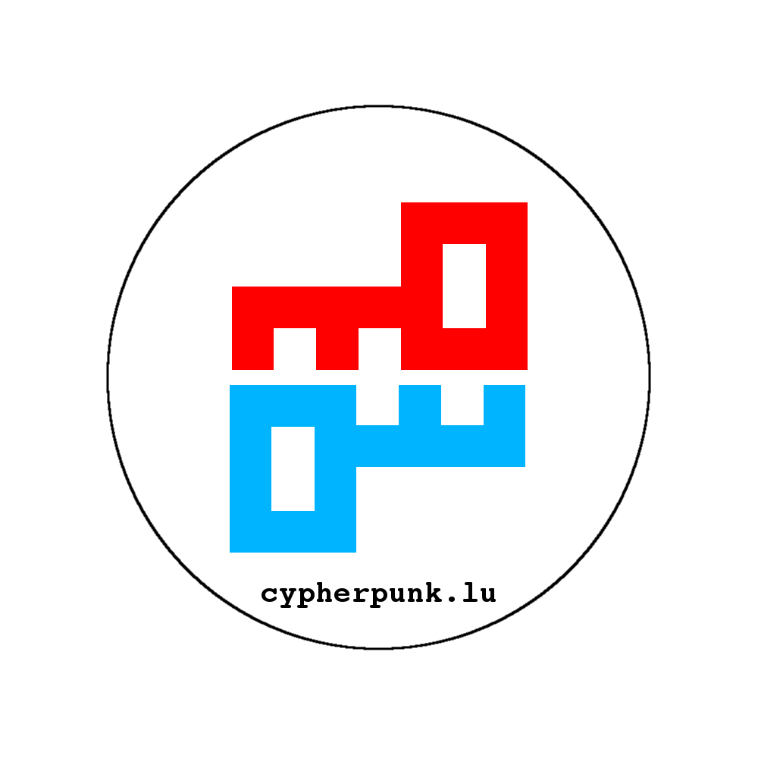
cryptoparty: Onward! is the first cryptoparty taking place in Luxembourg. We choose the topic Onward! to declare our stand for legal and mass spread cryptography over the world, starting for our corner in world.

Time & Place
When | 12th of January 2013, from 10 AM to open end
Where | Centre Barblé, rue des Romains (opposite of the commune), L-8041, Strassen, Luxembourg (Europe, Earth)
Map | Click here!
Please bring your notebooks!

Stay overnight?
- Luxembourg - Youth Hostel
- Booking.com - Hotels in Strassen
- Or just get in touch with us at info@c3l.lu and we're probably able to accommodate you at some place at our /home.

Keynote
Time | Subject | Description | User(s)
10h10 | Welcome Speech | Why? Who? What? | virii, rafiot, prometheus
10h20 | Cryptography & You | A short introduction into cryptography | virii, rafiot, trollchen

Lectures

Morning
Time | Subject | Description | Workshop / Lecture | User(s)
10h45 | Tor | What is Tor? | Lecture | Moritz Bartl
11h15 | TrueCrypt | Encryption for the masses | Lecture | virii
11h30 | PirateBox | Share Freely! | Lecture | virii
11h45 | VPN Setup | openVPN setup for fun and profit | Lecture | trollchen
12h00 | XMPP | OTR | Why XMPP gives you freedom & OTR keeps your chat sessions as private as never before | Lecture | prometheus
12h15 | gpg | Description | Lecture | rafiot
12h30 | metadata | What the heck? | Lecture | prometheus
12h40 | BigBrother.lu | Idea - Realization - Media Attention - Aftermath - NOW | Lecture | prometheus

Lunchbreak
Starting at 12h45 the lunchbreak should give you some space from everything you just learned. There is the opportunity to get sandwiches from our booth or get something to eat around the cryptoParty location:
- Pizza Hut
- Comedia Del Arte
- …

Afternoon
Time | Subject | Description | Workshop / Lecture | User(s)
14h00 | torservers.net | Running a community which provides Tor nodes | Lecture | Moritz Bartl
15h15 | Oldschool meets Newschool | PGP encrypted letters | Lecture | virii
16h00 | let me pass | hiding data in ICMP packages | Lecture | virii
16h15 | Just swallow it! | Encrypt your Arch Linux system with dm-crypt and hide the keyfile on a MicroSD Card and boot from it. | Both | prometheus

Workshops
Subject | Description | Workshop / Lecture | User(s)
XMPP | OTR for Beginners | Installing related Software, registering account, til using it will be explained in this workshop. | Both | prometheus
PirateBox | Get your hands dirty | Workshop | virii

Lightning Talks
Lightning Talks don't last longer than 5 minutes and are meant to tease your curiosity about a topic or simply to make you aware of a something, you might have not known yet. If you'd like to do a Lighting Talk, please don't hesitate to contact: info@c3l.lu or ask a staff person on the conference.

Let's socialize
A cryptoParty without a really party, wouldn't be a cryptoParty. To conclude the lectures & workshops, we finish up with the Keysigning Party and afterwards focus all our efforts on Club-Mate, the Hackcenter and the good music!
Time | Subject | Description | User(s)
6PM to 8PM | KeySigning Party | Trust process initialized | prometheus
9PM to OpenEnd | CryptoParty | Music, Tshunk & Hacking | everyone
Permalink: http://ur1.ca/cfkxn

Media Files
- Watch a behind the scene video of Jan GUTH talking about Cryptoparty and crypto in general ( Luxembourgish! )
- Have a look at some Presentation Slides

