hack.lu 2016
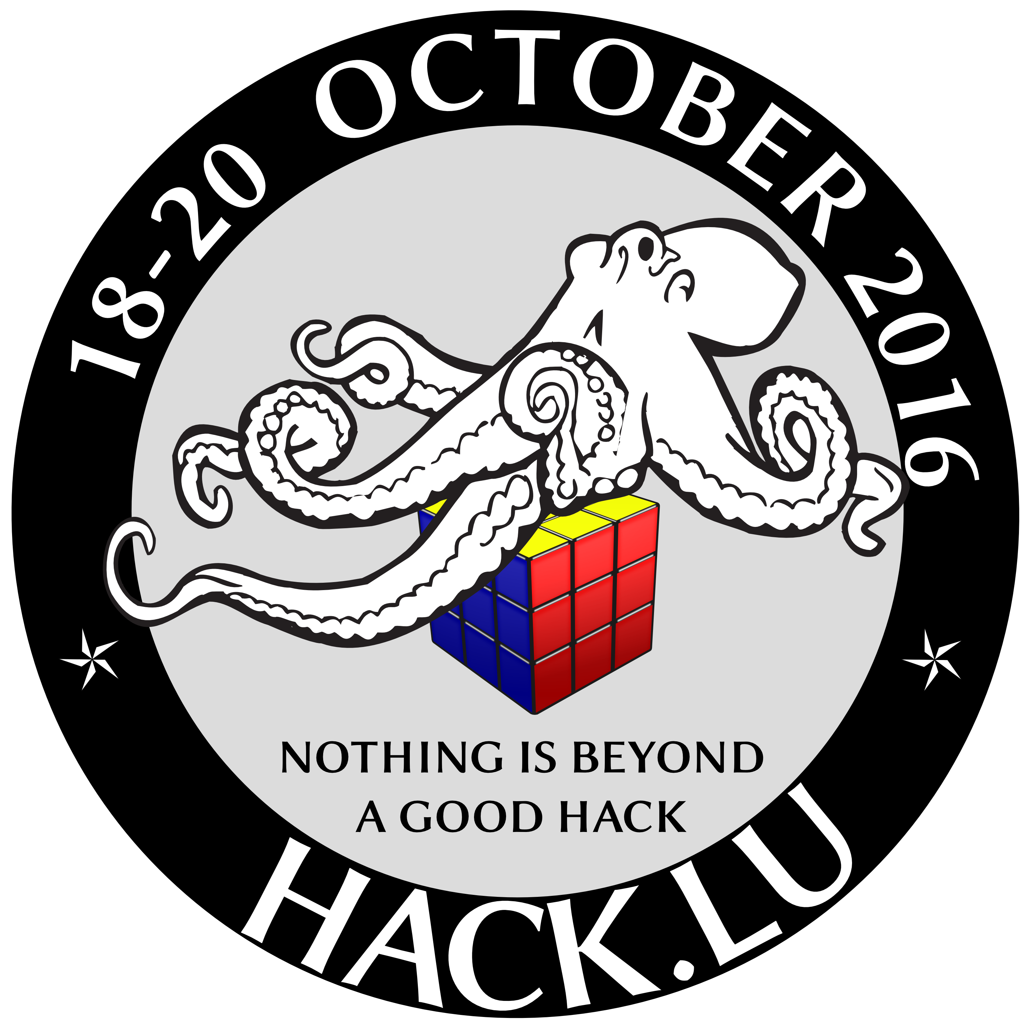
Date | 18-20th October 2016
Time | All-Day Event
Venue | Alvisse Parc Hotel, 120 Route d'Echternach, 1453 Dommeldange, Luxembourg
Description | Hack.lu is an open convention/conference where people can discuss about computer security, privacy, information technology and its cultural/technical implication on society. The aim of the convention is to make a bridge of the various actors in the computer security world.
Flyer (PDF) | N/A
Website | http://2016.hack.lu/
Contact | prometheus
Participants | virii, prometheus, orimpe, muling

Tor Relay Operators Meet-Up
Date: 19th of October 2016 \\Time: 16h00

Minutes

Impressions

