Hack.lu 2017
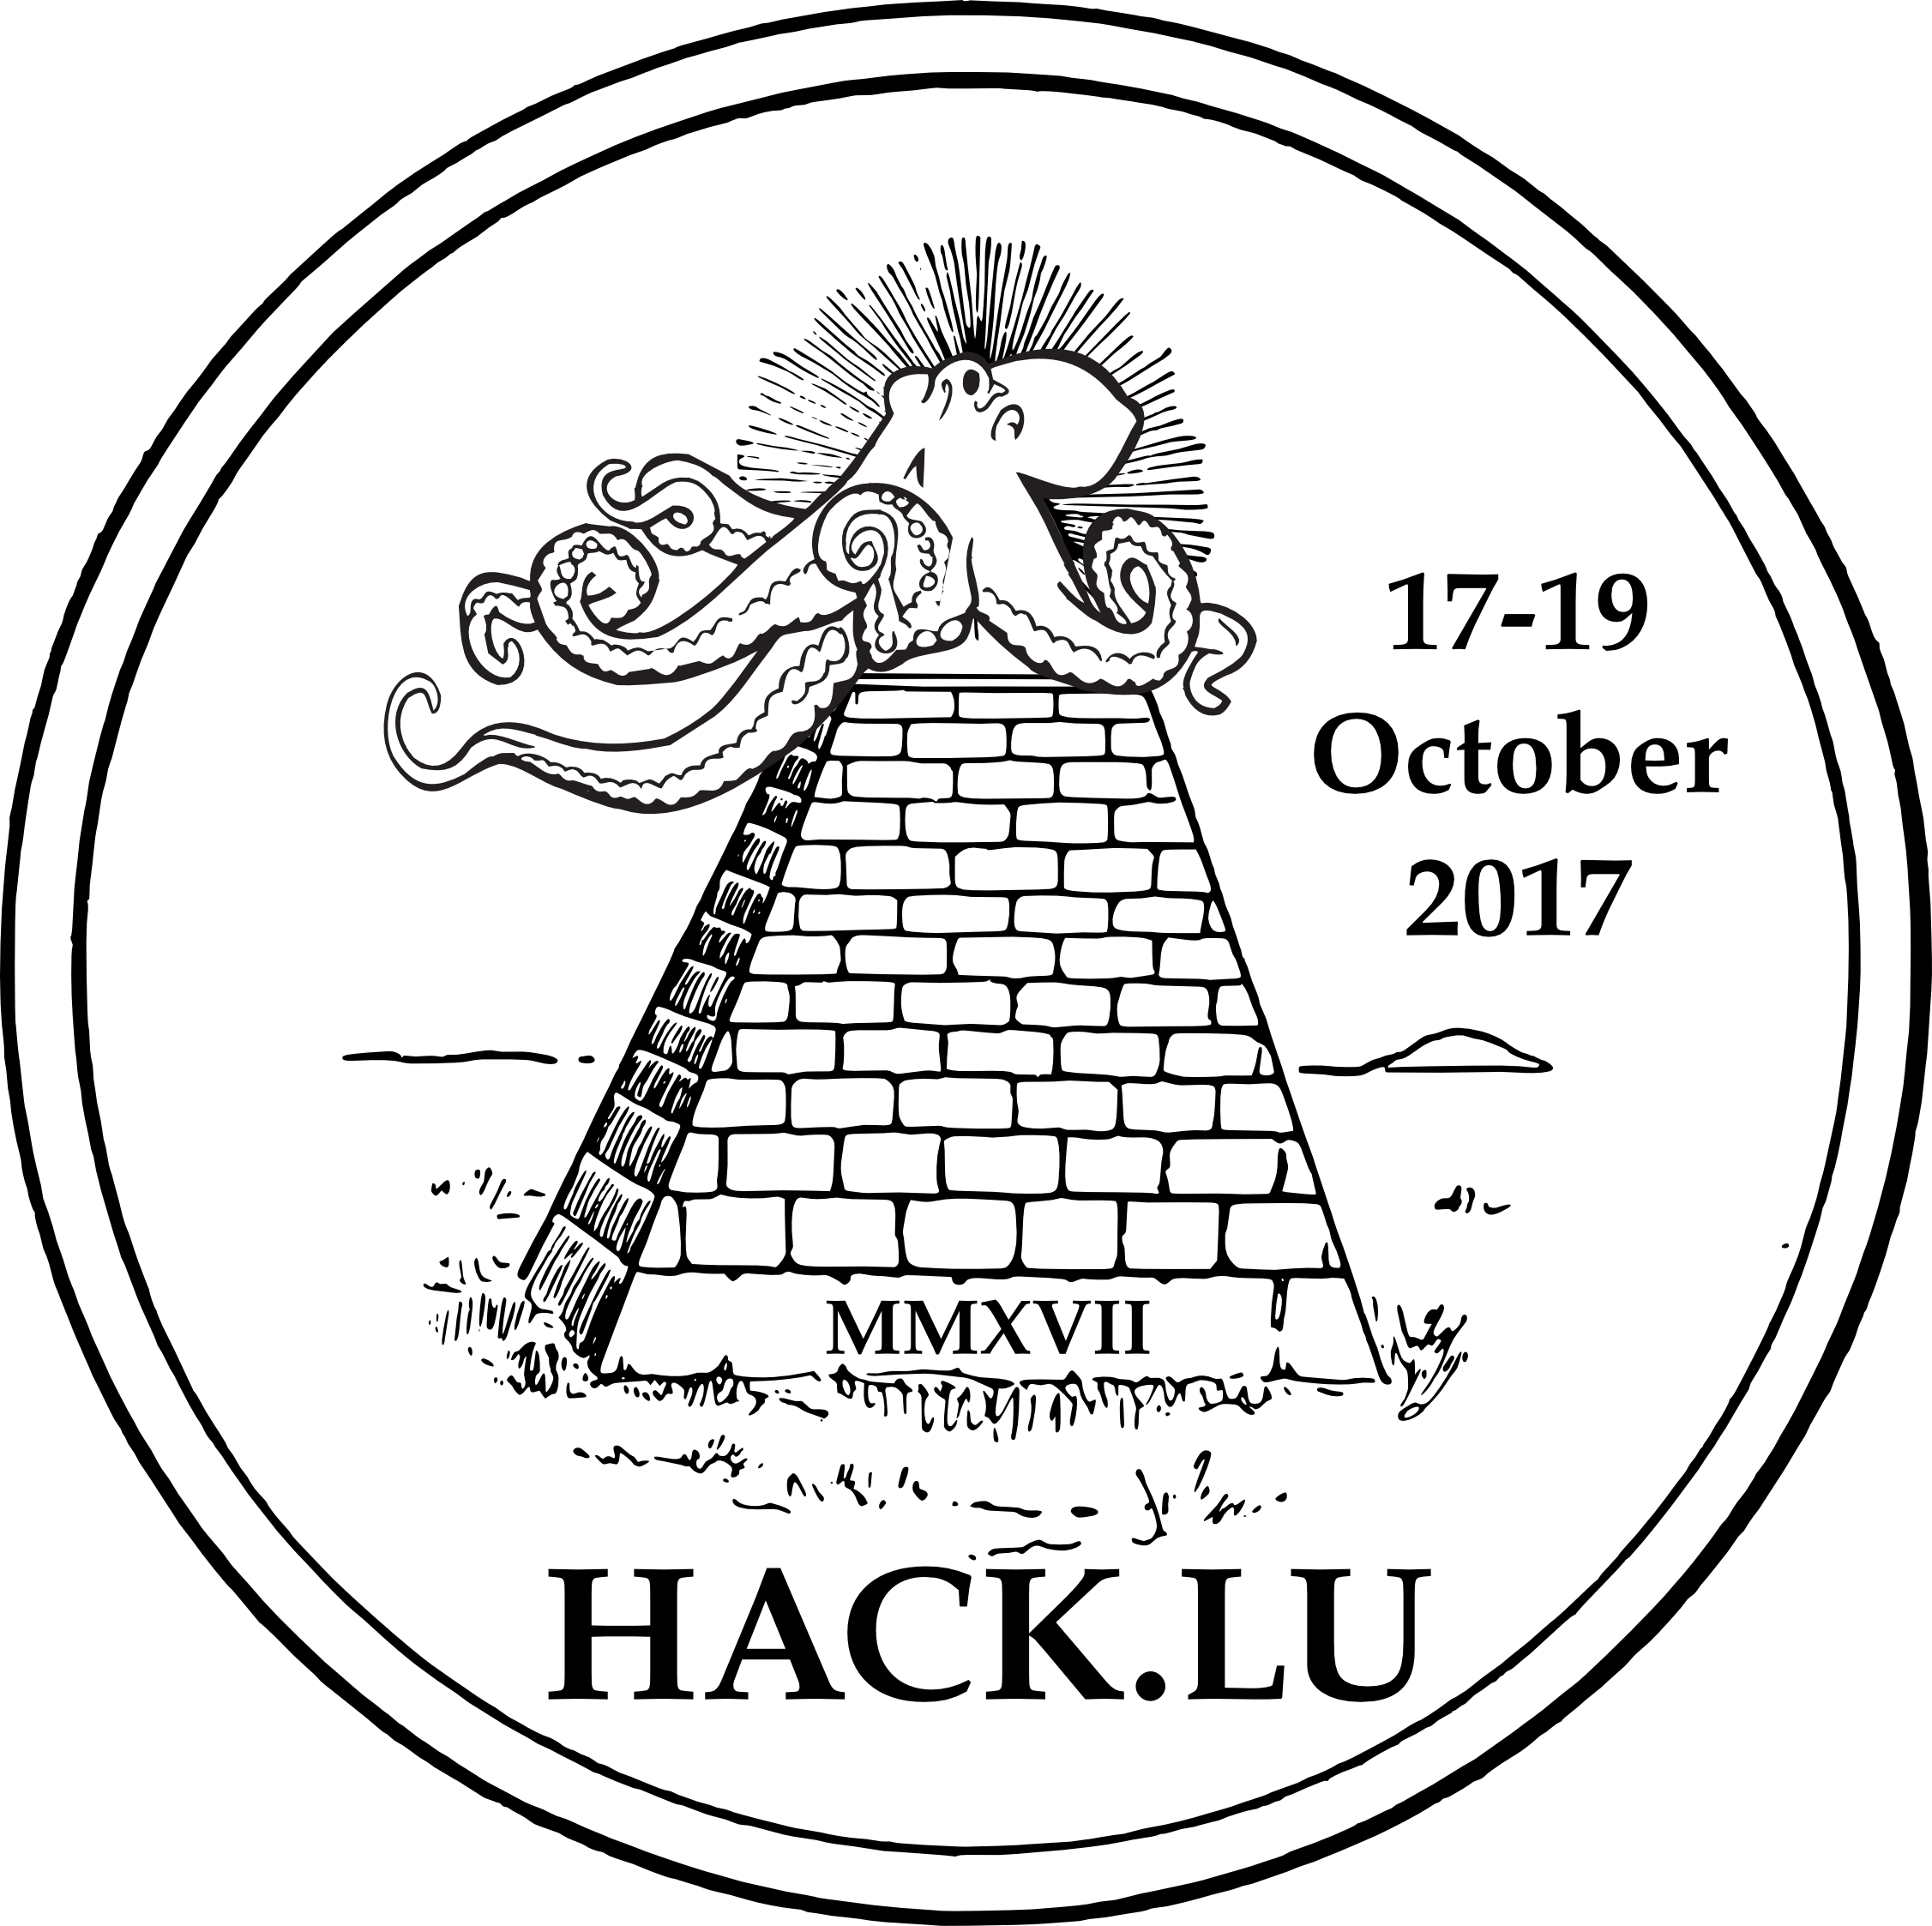
Date | 17/10/2017 - 19/10/2017
Time | 08:45 (local time)
Venue | Parc Hotel
Description | Hack.lu is an open convention/conference where people can discuss about computer security, privacy, information technology and its cultural/technical implication on society. It's the 13th edition (17-19 October 2017) of hack.lu in Luxembourg.
Website | https://2017.hack.lu
Contact | fantawams
Participants | metalgamer fantawams

Pricelist:
Book | Price
The Black Box Society | 25€
Spam Nation | 20€
For the Win | 15€
Beautiful Trouble | 30€
The Cuckoos Egg | 20€
Ghost in the Wires | 15€
Machine Learning | 20€
Weapons of Math Destruction | 15€
Homeland | 20€
Gimmicks | Price
Hackerspace Passport | 10€
RFID Passport Protection | 15€
RFID Creditcard Protection | 5€
Tor Poster | 5€
Freifunk Poster | 10€
Soldering Kit - Tux | 10€
Soldering Kit - Conway's Game of Life | 20€
Drinks | Price
Flora Power | 2€ + 1€ Deposit
Beer | 2€ + 1€ Deposit

feedback
- The Cuckoos Egg gouf bal ganz verkaf.
- Flora ass rem gutt verkaf 3 Kagoen.
- Soldering kits goufen guer net verkaf
- Stickeren sinn wie nix weg gaangen
- Den 3D-Printer muss dobäi sinn, vir Leit unzezéien.
- Freifunk ass gutt gang, villäicht nächst Joer vill domadder mat organiséieren
- HackLU halt, vill Business
- Freifunk Flyeren mussen op englesch do sinn.
- Béier ass guer net kaf ginn 1 Kago.-
- Mei tweeten

