Hack.lu 2019
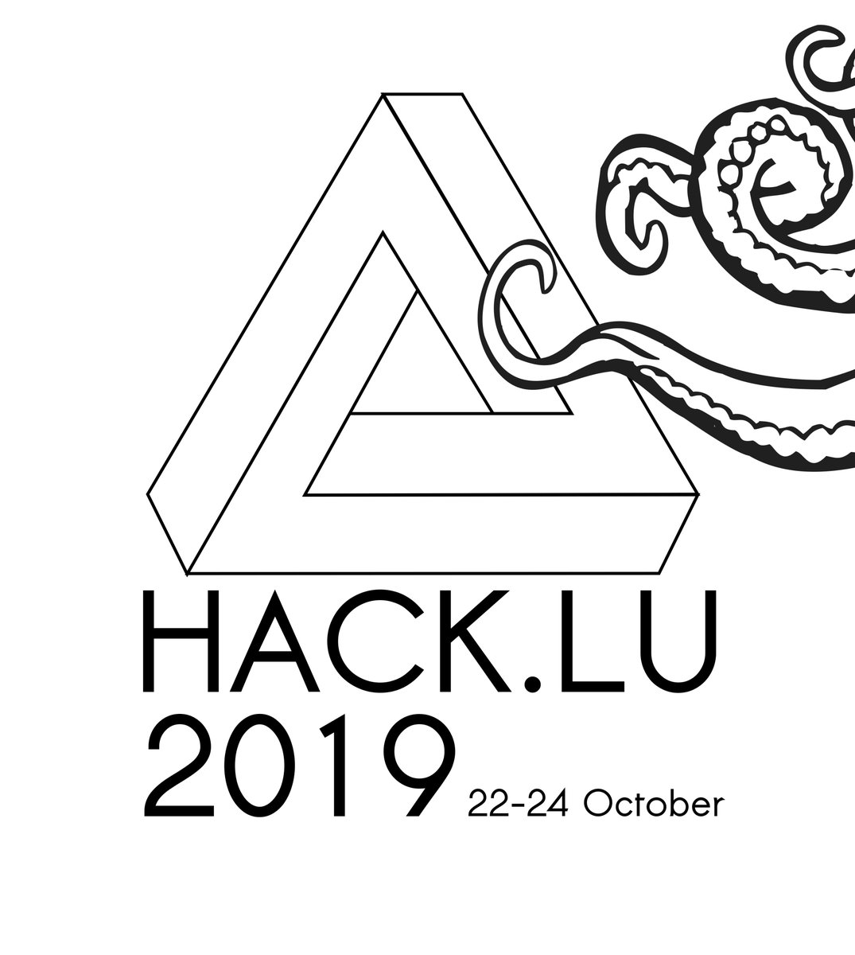
Date | 22/10/2019 - 24/10/2019
Time | 08:45 (local time)
Venue | Parc Hotel Alvisse
Description | Hack.lu is an open convention/conference where people can discuss about computer security, privacy, information technology and its cultural/technical implication on society. It's the 15th edition (22-24 October 2019) of hack.lu in Luxembourg.
Website | https://2019.hack.lu
Contact | fantawams
Participants | fantawams virii orimpe deflenken

