36th Chaos Communication Congress (36C3): Resource Exhaustion

Date | 27/12/2019 - 30/12/2019
Venue | Leipzig Messe - chaosstuff (For Congress Everywhere)
Description
Website | Blog Wiki Fahrplan
Contact | metalgamer
Participants
halfnarp

Congress Everywhere
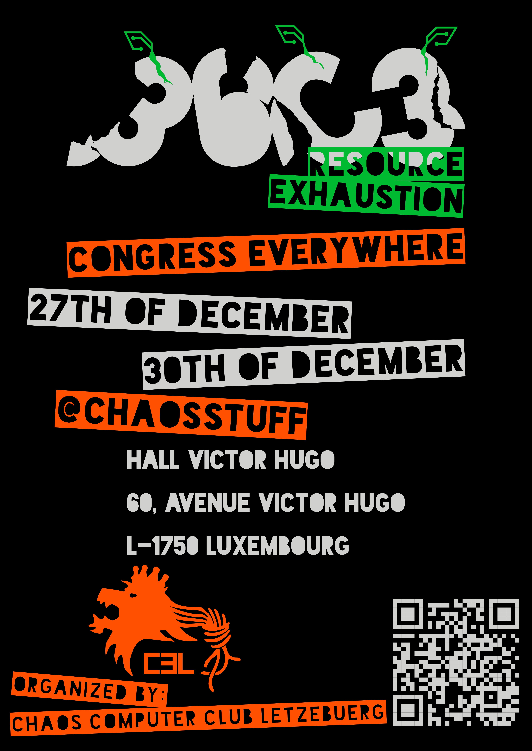
Come by and get social. We will of course watch the streams. There will also be Tschunk.

