[h]ackyard 2017: Bleesbréck - FAQ
Back to main page

Venue
Address
Camping Bleesbréck
1, Bleesbréck
L-9359, Bleesbréck/Bettenduerf
Luxemourg, Europe
Coordinates:
Longitude: 49.87469
Latitude: 6.18806
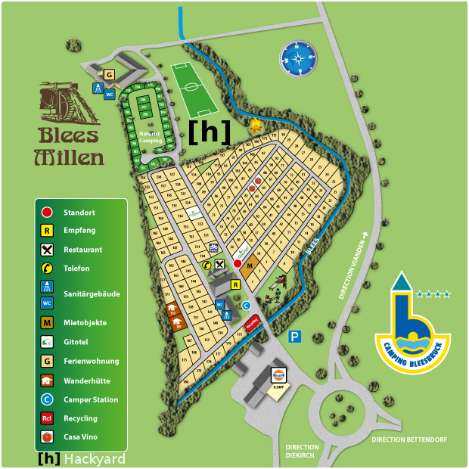
Online Map

Tickets
This is an invite only event with limited places. C3L members will have priority, but this year we invite some folks from the greater region.
Get in touch with info@c3l.lu for further information.
But if someone want come round to the camp for a few days, we have also Daypasses for 10€ (24h).

What you need to...
bring on your own:
- tents
- food (or share stuff in exchange for food - barbecue grill provided)
- waterproof clothes in case of rain (it's in the Éislek, so "Schloreen" is not uncommon)
- basic camping stuff (knife, fork, plate, etc)
- bring something to share. Movies, Food, Stickers.
know:
- Toilets & showers are freely accessible.
- Even if there is water in Club Mate & Flora Power, we urge you to drink bottled water from time to time.
- Accepted payment methods: Euro, BitCoin, Share Economy.
- Don't expect a stable internet connection. :P

Food & Drinks

Drinks
You can buy drinks at the camp. Here you can find an list with all the available drinks and prices.

Food
Since we will have nice weather, we will grill, bring your own food or buy it local around the camp. Perhaps someone will cook something delicious for everyone in a workshop, but be warned everything will be grilled on the same grill, be it meat vegetable or cheese. Find more information about the workshops in our Fahrplan.

