This page is not fully translated, yet. Please help completing the translation.
(remove this paragraph once the translation is finished)

Spenden
Een Club lieft net nëmmen vun sengen Memberen mee och vun Suen.
Hei fannt der eng kleng Iwwersiicht vu Projete wou mir am Moment eng kleng Spend gutt kéinte gebrauchen.
Keen Projet fonnt deen der wellt ennerstezten? Gidd Member Join us an lanceiert ären eegenen Projet.



Mir freen eis iwwert all eenzel Spend.
Mir akzeptéieren Bitcoin, cash via mail an natierlech och wire transfers!

Projeten
Hei ass eng lëscht vun Projeten déi am Moment frou wieren finanziell Hëllef ze kréien:
- YAB - Yet another Bar
- Frënn vun der Ënn - Tor Exit Node Hosting
- Freifunk - Public WiFi done right!
- Ultimaker 3
- CNC-mill

Bank Informatiounen fir eng Spend ze mann
Account-Holder: Chaos Computer Club Lëtzebuerg
BIC/Swift: BCEELULLXXX
IBAN: LU29 0019 2855 3890 4000
Communication: Donation $PROJECTNAME

Bitcoin
BTC Adress: 3BV5UPToMUmXJiqUVndHjSSq2HqDW8npRd

Of course you can also donate without specifying a certain project!
Use the Bank details above or use this Bitcoin QRCode (10€ donation). Bitcoin donations are very welcome and prefered! Please note that if you want to help out a specific project then you must provide the name of it in the communication field.
Bitcoin Adress: 3BV5UPToMUmXJiqUVndHjSSq2HqDW8npRd

Webshop
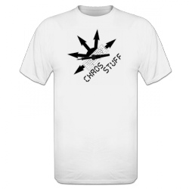
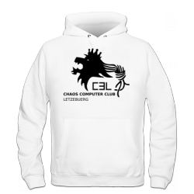
Hei kennt der Kleeder an nach aner Saache mat eisem Logo drop kafen outsourced online shop.
Wann der wëllt Saache wei z.B. T-Shirts mat Bitcoin bezuelen dann benotz ee Service wei Bitwala.

Membership
Kukt Iech d' Memberschaft un.

Bankkonto
Account-Holder: Chaos Computer Club Lëtzebuerg
BIC/Swift: BCEELULLXXX
IBAN: LU29 0019 2855 3890 4000
Communication: Membership Fee $YEAR $USERNAME

Bitcoin
BTC Adress: 3BV5UPToMUmXJiqUVndHjSSq2HqDW8npRd
For every person wiring their yearly membership fee, please use Membership Fee $YEAR $USERNAME as communication.
If you use Bitcoin for your membership fee you need to mail us the Transaction ID for verification.

