This page is not fully translated, yet. Please help completing the translation.
(remove this paragraph once the translation is finished)

Freifunk Meetup
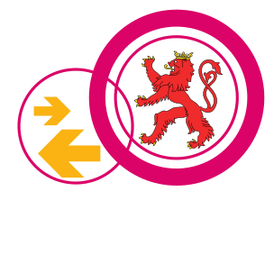
Freifunk Meetup's take place every third Monday (outside of our ChaosMeeting Mondays) at 19PM (but the space is probably open before that, check the space status here) in the clubs hackerspace. Everyone can join the Freifunk Meetup and talk with the national Freifunk community. Here you can also get a preconfigured Freifunk router.

