Some Rock-A-Field attendees stand with Snowden!
For a lot of people living in Luxembourg it already became a tradition to head out on the field for the Rock-A-Field every year in Roeser. But this year was kind of special. I wanted to bring a piece of (h)acktivism with me and use the opportuniy to talk to people about Edward Snowden.
Thanks to the campaign of the Courage Foundation (see previous blog post), I wanted to spread the word about it on the festival. Below you find 3 results, but more hide behind the new project we have launched with it: Stand with Snowden!
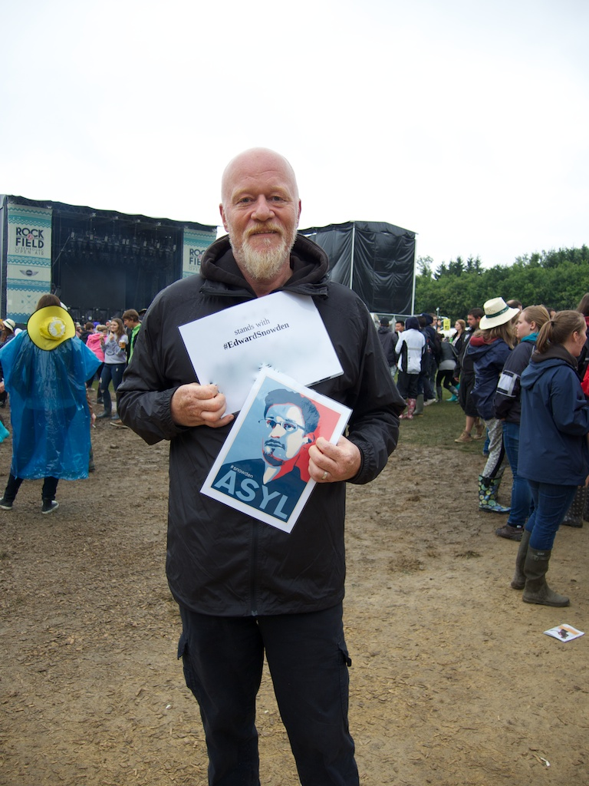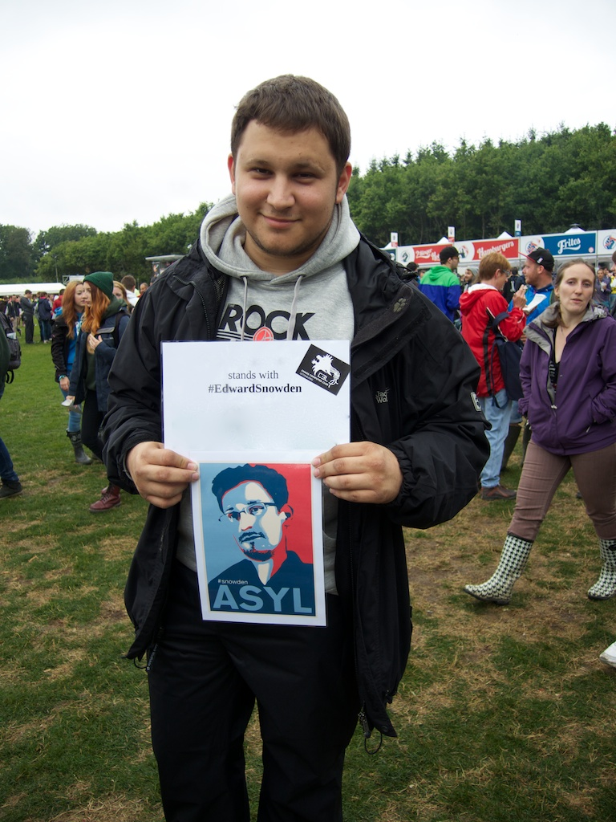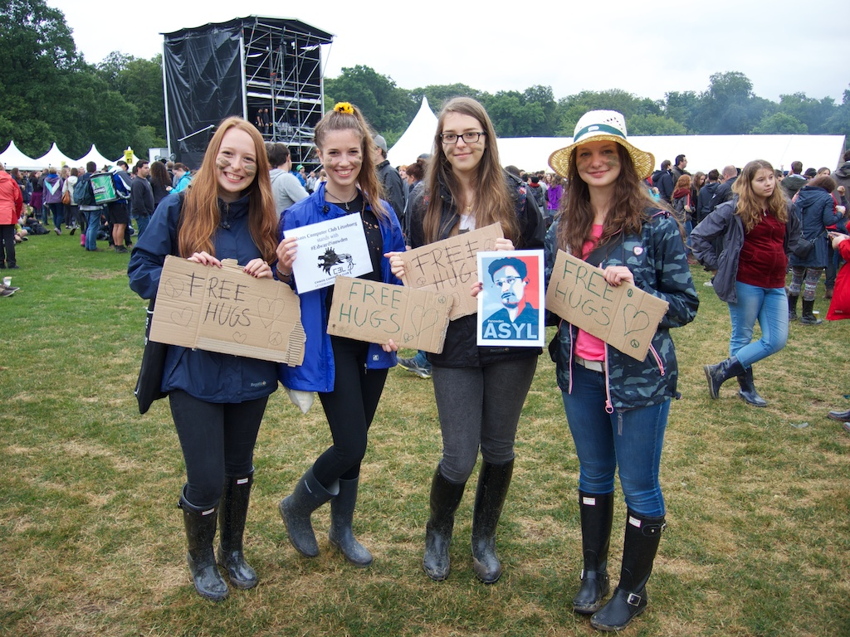
Read more about it on the regarding wiki page. :)

