Last Summer Dance
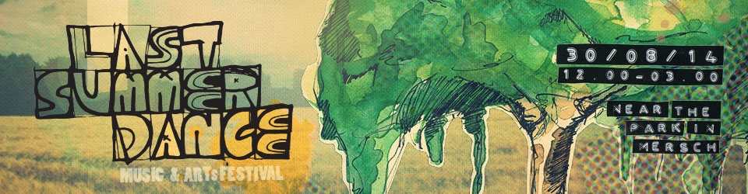300
C3L will attend Last Summer Dance festival with a talk about media competence / education & Net Neutrality. We'll start around 3PM.
Check out the schedule for more information. :)

