Freifunk Meetup
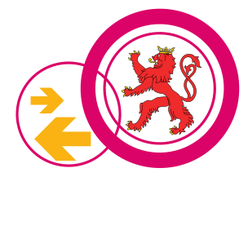
Freifunk Meetup's take place every third Monday (outside of our ChaosMeeting Mondays) at 19PM (but the space is probably open before that, check the space status here) in the clubs hackerspace. Everyone can join the Freifunk Meetup and talk with the national Freifunk community. Here you can also get a preconfigured Freifunk router.

Minutes 2023
- Freifunk Meetup 2023/01

Minutes 2021
- Freifunk Meetup 2021/02
- Freifunk Meetup 2021/01

Minutes 2020
- Freifunk Meetup 2020/01

Minutes 2019
- FreiFunk Meetup 2019/01
- FreiFunk Meetup 2019/02
- FreiFunk Meetup 2019/03

Minutes 2018
- Freifunk Meetup 2018/01

Minutes 2016
- Freifunk Meetup 2016/01

