2D-Image to 3D-STL
Project | 2dimage-to-3dstl
Description | Convert a 2D-Image to an 3D-STl for your 3D-Printer
Status | completed
Contact | fantawams
Participants: | /
Author: fantawams

What do you need
- An image, preferably SVG or at least a high-res version of it.
- A PC, preferably with Linux installed. ;)
- An idea of what you want to do with your STL later on
- Internet

Some basic Info
You will learn, how to turn your 2D Logo/Image into a 3D STL, which you can use in most other 3D-CAD programs. Yes I wrote „most other“ and not „all“ 3D CAD program. You might ask yourself now, why I did that but there is a very simple reason. There are 2 STL versions, one is build on a binary core, the other one on an ASCII core. But fear not, you will learn in this guide, a way where it doesn't matter witch STL-version there is and you will see it work on an example with lots of pictures.
The way your going to learn is tested and verified on an Ubuntu 15.10 OS, I will announce, but not explain, a few other methods which would work but didn't work for me because of multiple reasons. Thanks to our member orimpe and some guidance from the C3L it was possible to get to the mark, so a small donation, as thanks, would be nice and very much appreciated. To make it more actractive, take a look at our donations gifts.

Prepare you PC
To convert an 2D logo into an 3D STL, your going to need to install the program Inkscape, OpenSCAD, an CAD like freecad, an account for tinkercad and an extension for Inkscape. All those things don't cost a thing.
Inkscape 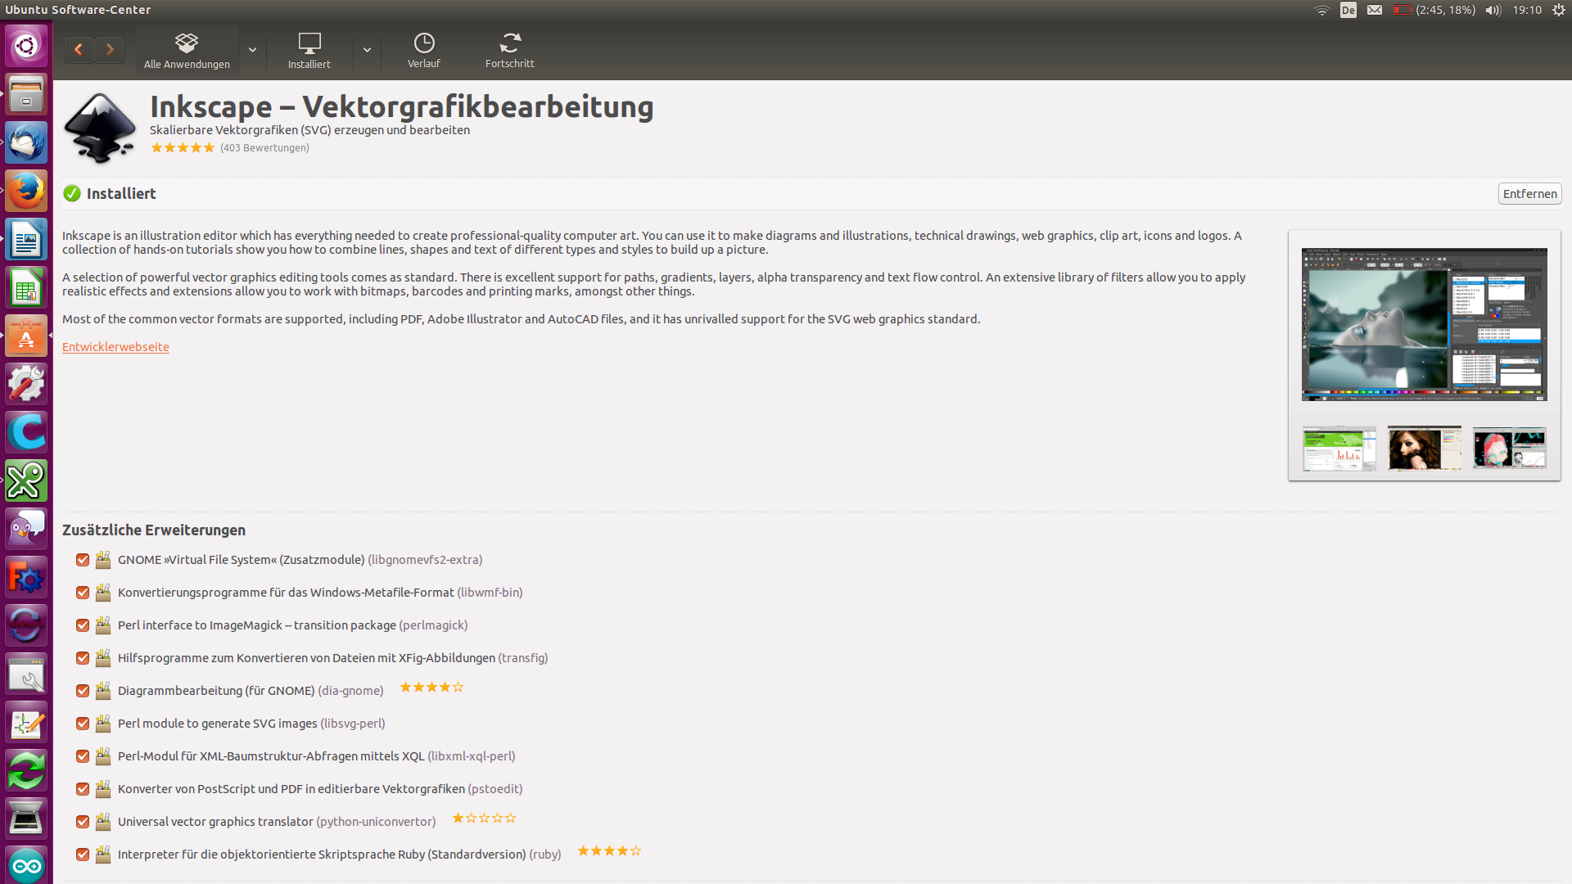
OpenSCAD 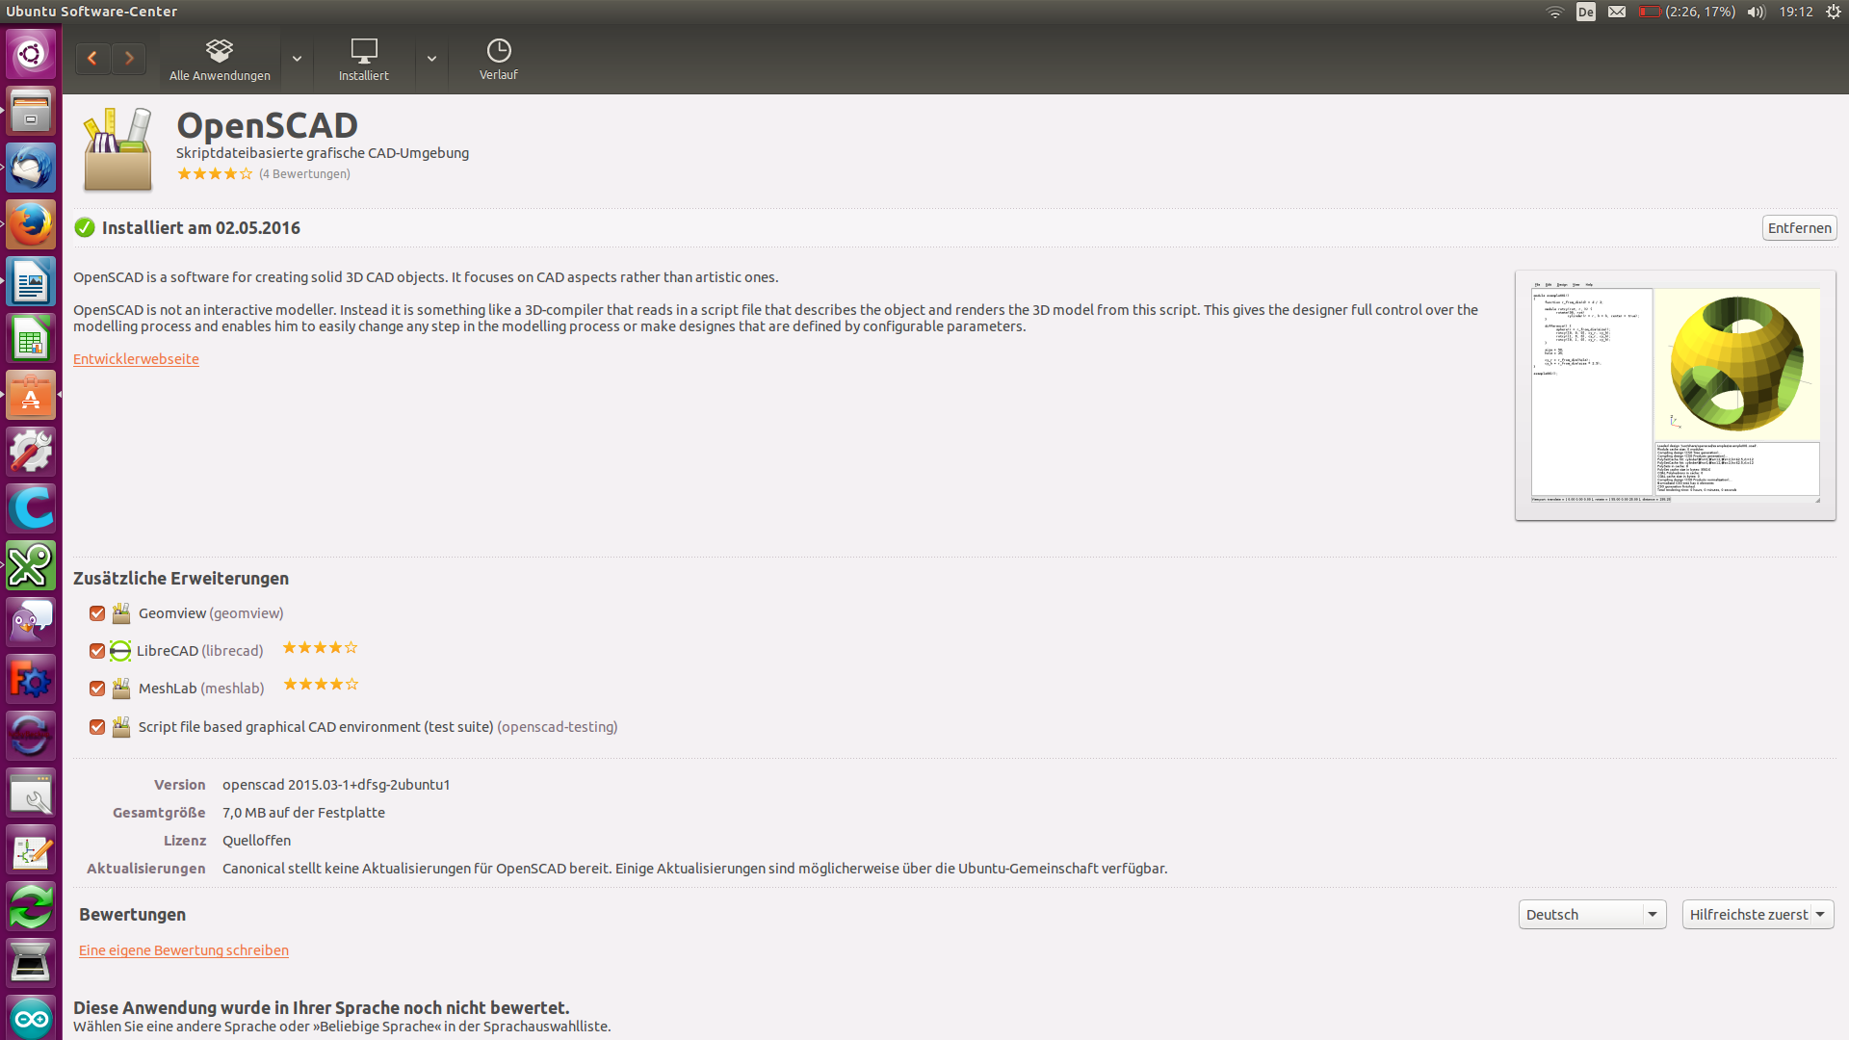
FreeCAD 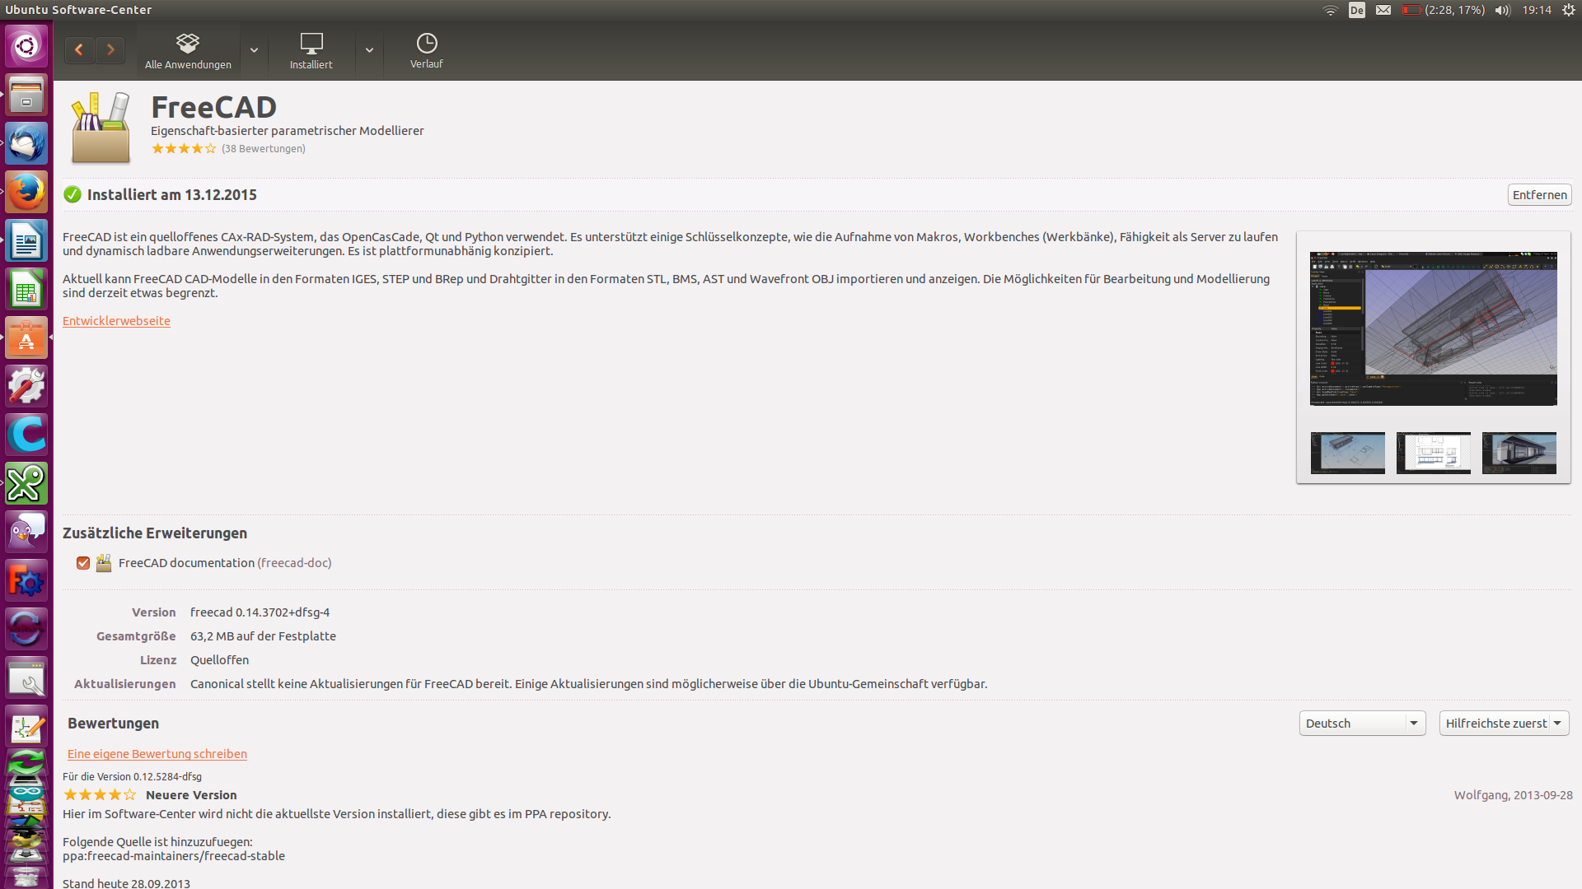
https://www.tinkercad.com/ Make an free account an do the first 3 lessons, so you know the basics about tinkercad.
The extension, you will find here: https://www.thingiverse.com/thing:25036
Now copie the 2 files into your extension folder of inkscape, perhaps you need to use the command-line cp to do that. Here is an example how you use cp for it:
sudo cp „from file destination“ „to folder destination“
Now open Inkscape and look under extension/create out of path/ there should be something like „path to Open SCAD“. If not, than the extension is not copied correctly.
Now that your PC is prepared, let's start working with it.

Converting your Image
First open Inkscape and load your Image, remember it is best to use an black and white image and in an SVG format.
Now click one time on your Image and use your new extension. 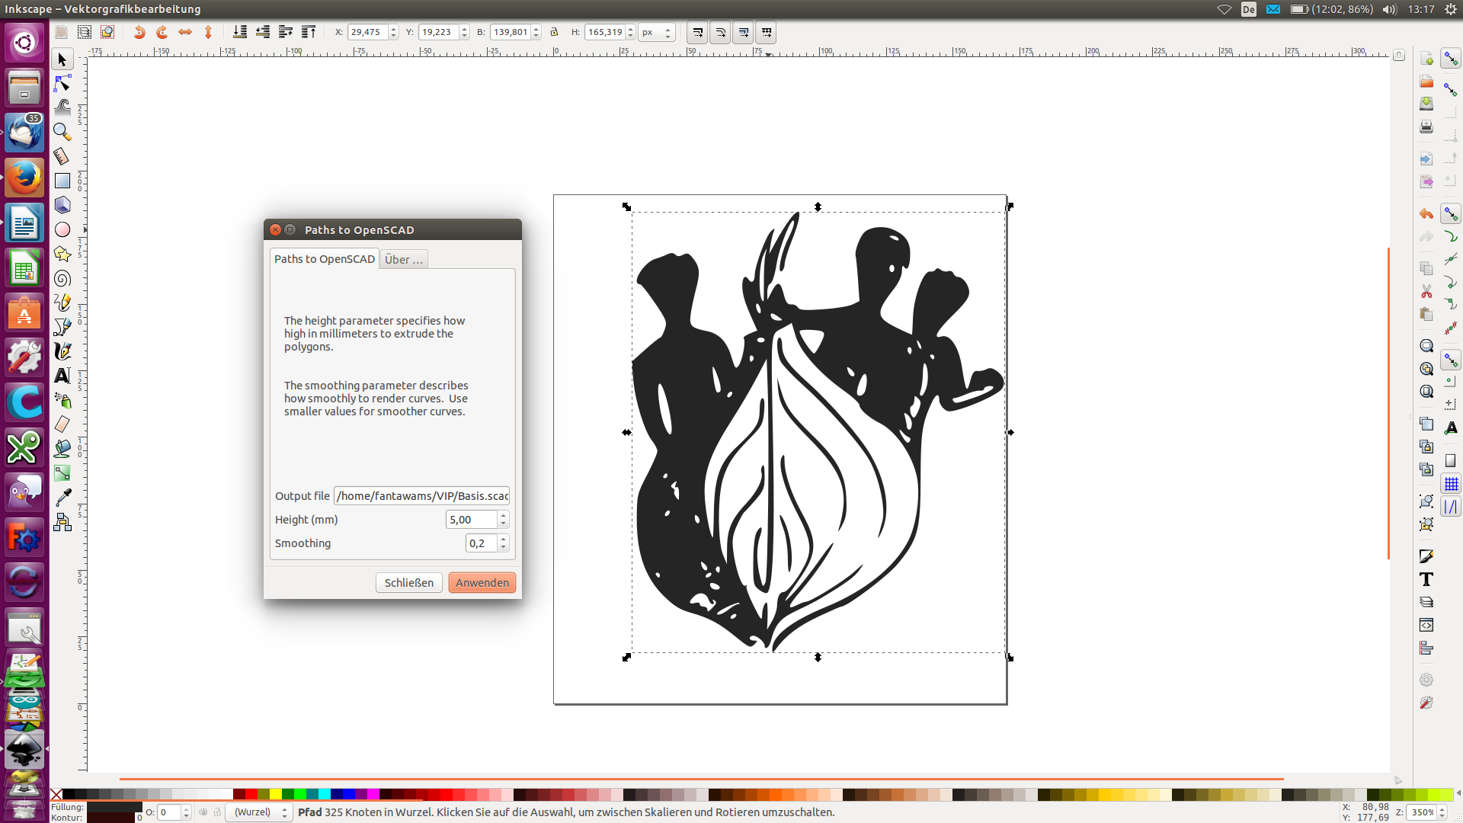
Now check if in Output file is something like this: /home/fantawams/VIP/Basis.scad. On the first time there might be an ~ before /home, if you have that delete the ~ or you won't be able to save your scad-file. Change your Hight as you want to, this determines how high or thick your peace will be . Next click OK to create an SCAD-file.
Now open your new scad-file with OpenSCAD.
Next click on Design and Render. That will take some time to finish the process. After the process is finished, export your object as STL. 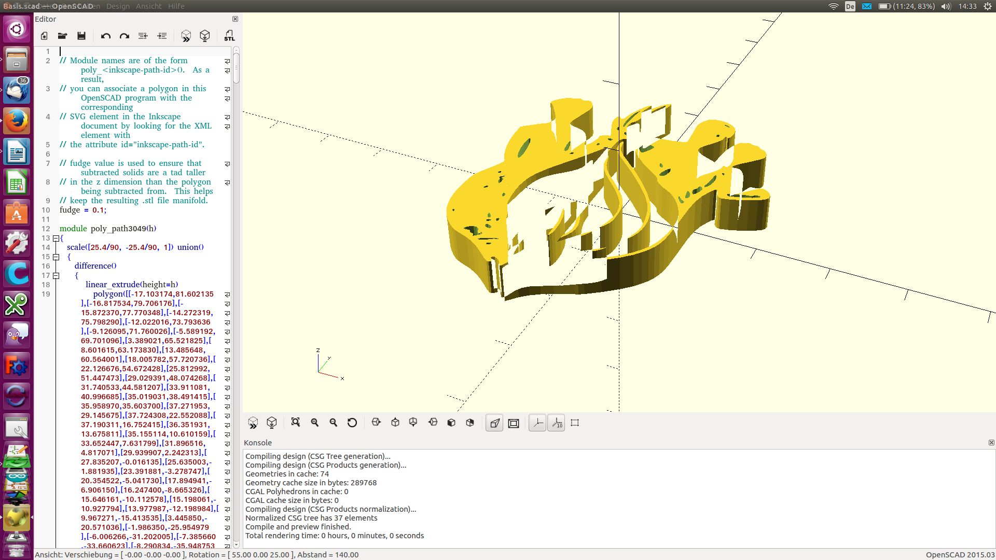 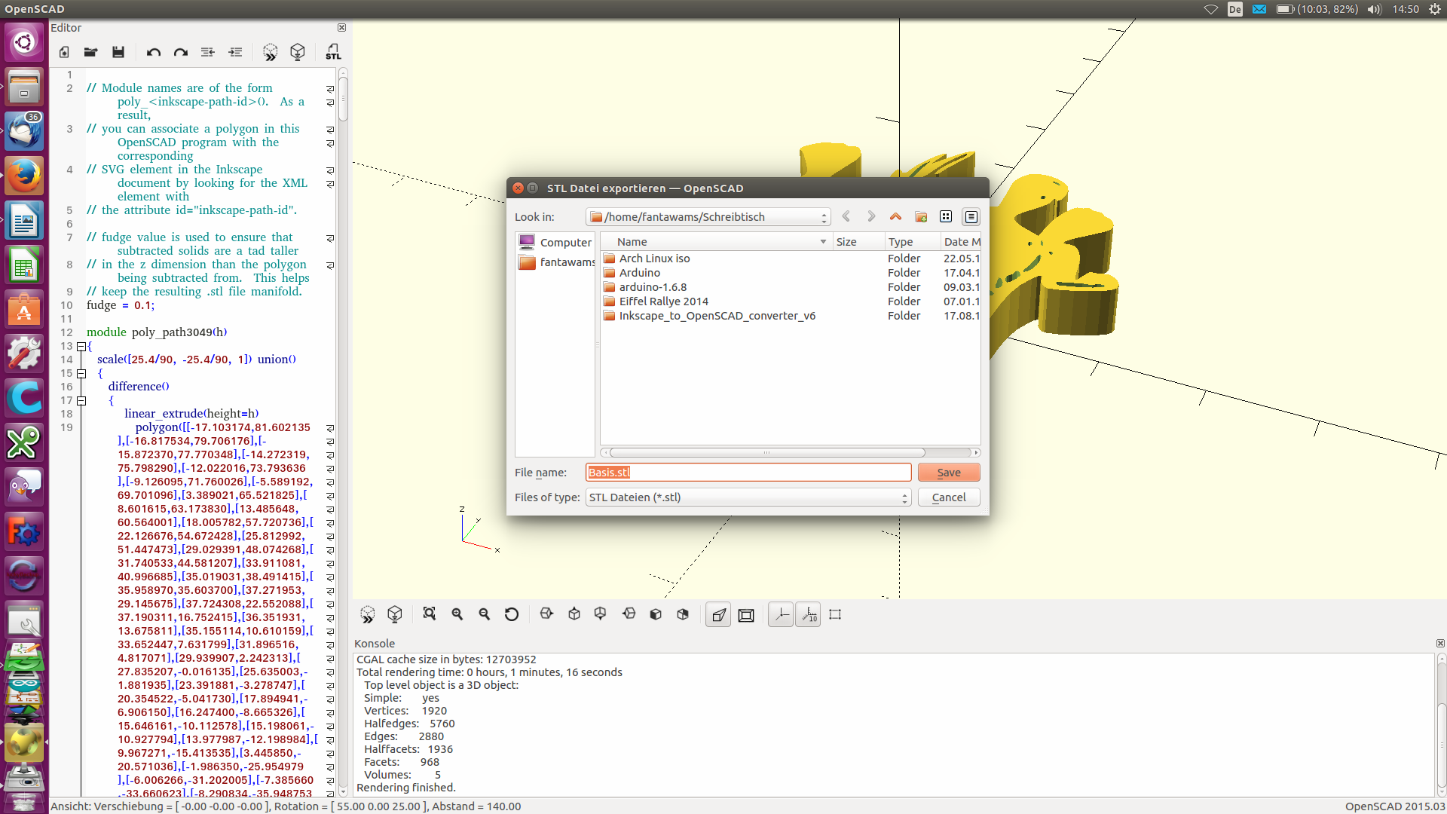
So now you have you 2D logo as an printable STL, if you like, you could print it now or you could edit it like in our next step. 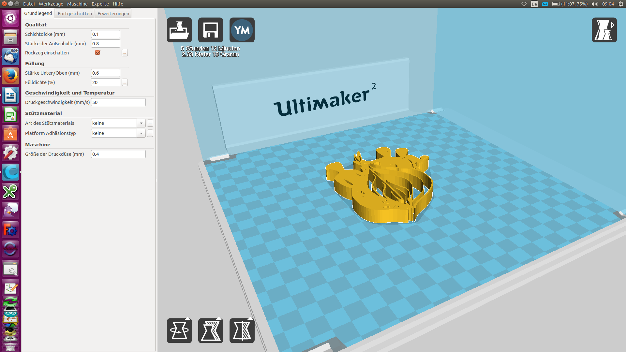

Editing your STL with tinkercad
Before we start, here are 2 alternatives of editing your new STL-logo: Meshmixer: it is an very easy to use program with which you can edit your STLs like you want to, combining or making a difference is no problem for it. Blender: Blender is the ultimate tool, you can do what you want but it is very complex and complicated. So it's difficult to learn.
We are going to use tinkercad for it. First of all import your STL-logo into tinkercad. 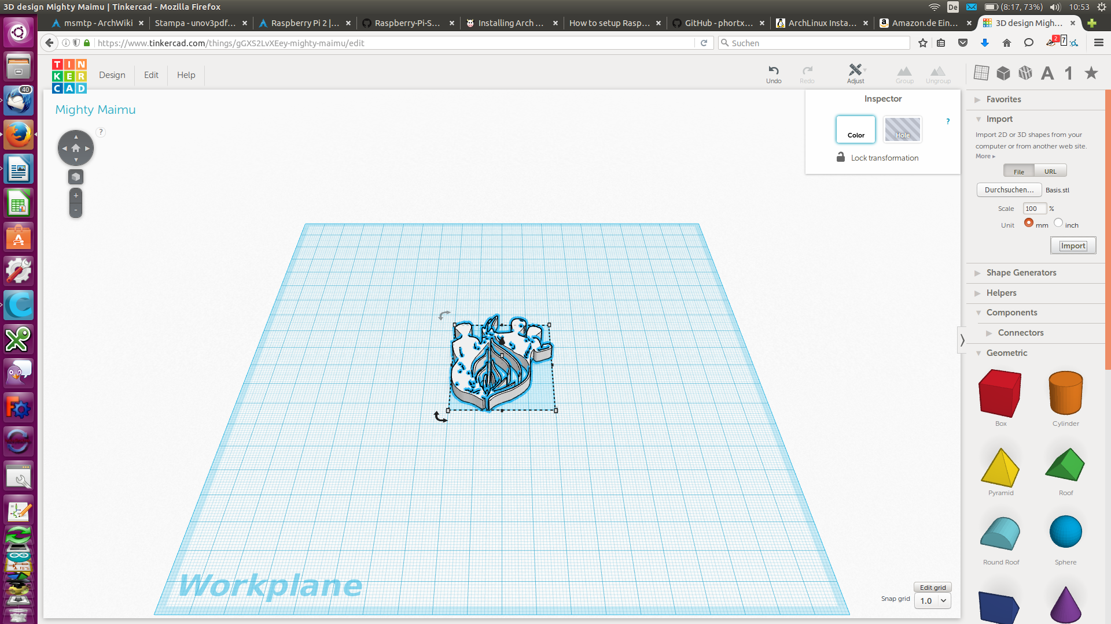
Next import an second STL which you draw in you CAD-program or draw one in tinkercad.
If you want to combine these 2 STLs, than move them together and select both of them. Than Click „Group“. 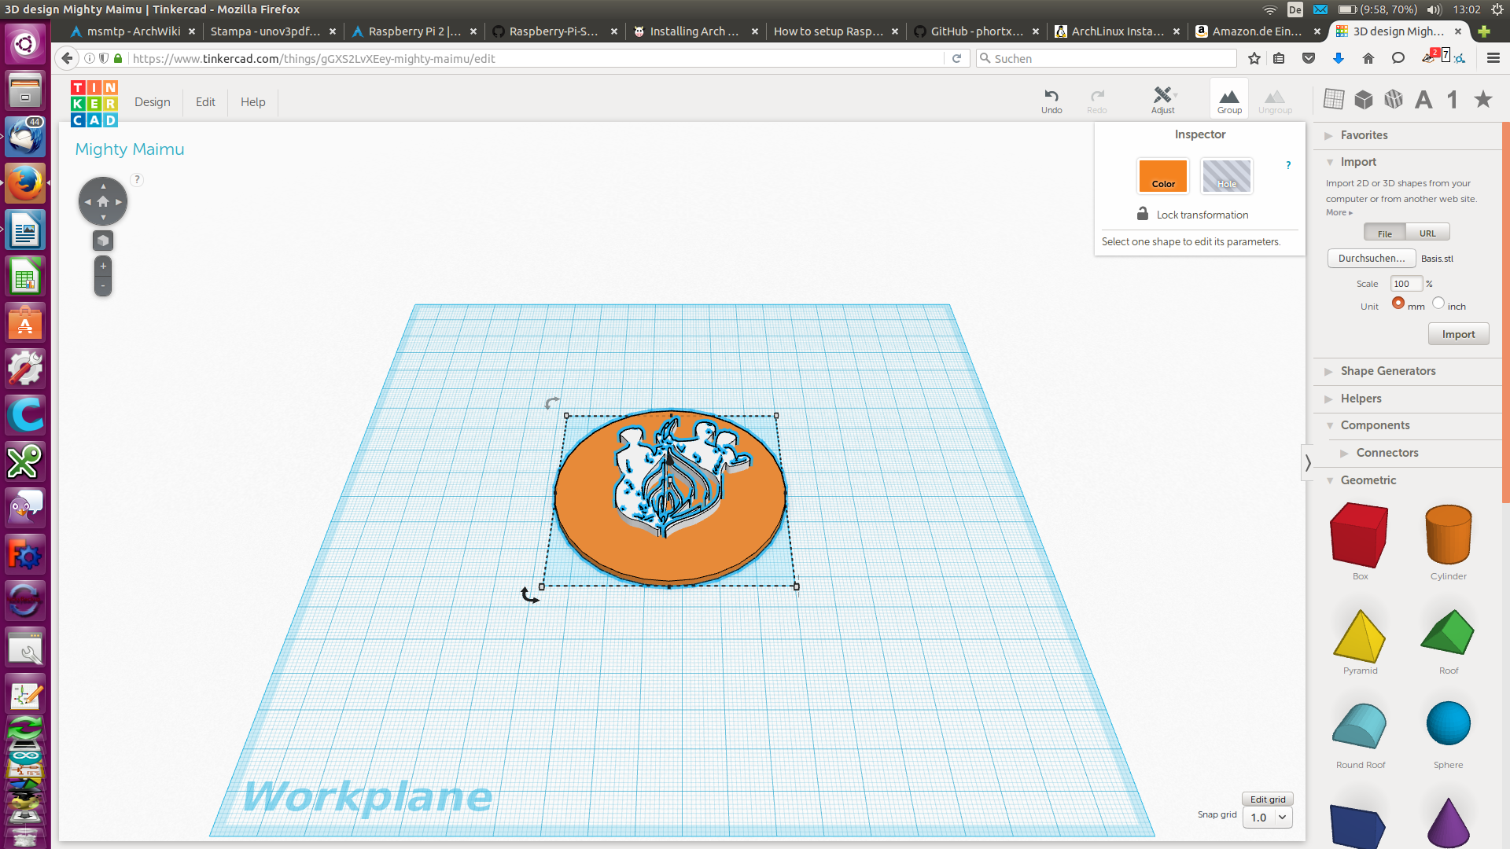 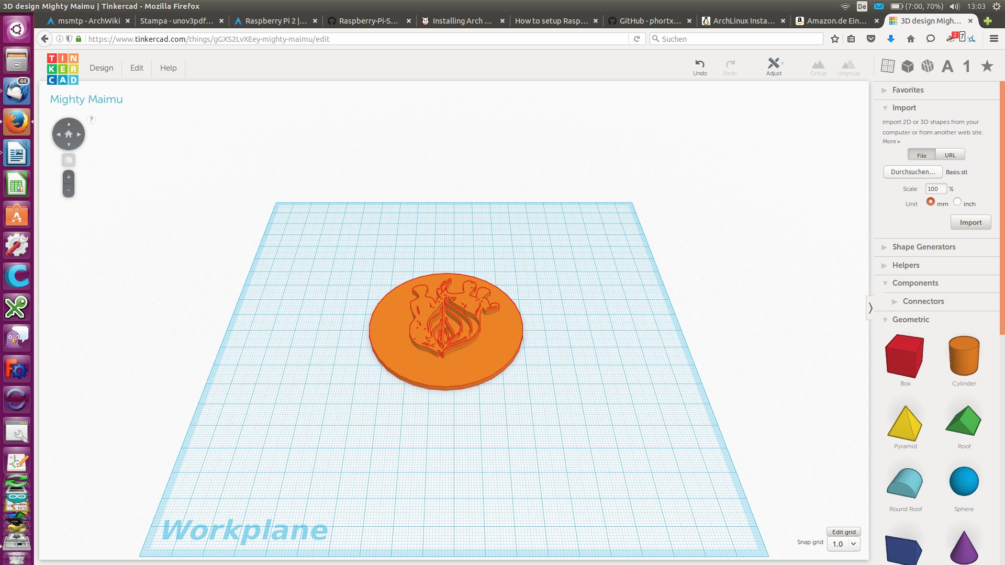
If it should be an difference of both of them, than make them an „Hole Tool“ before you group them. 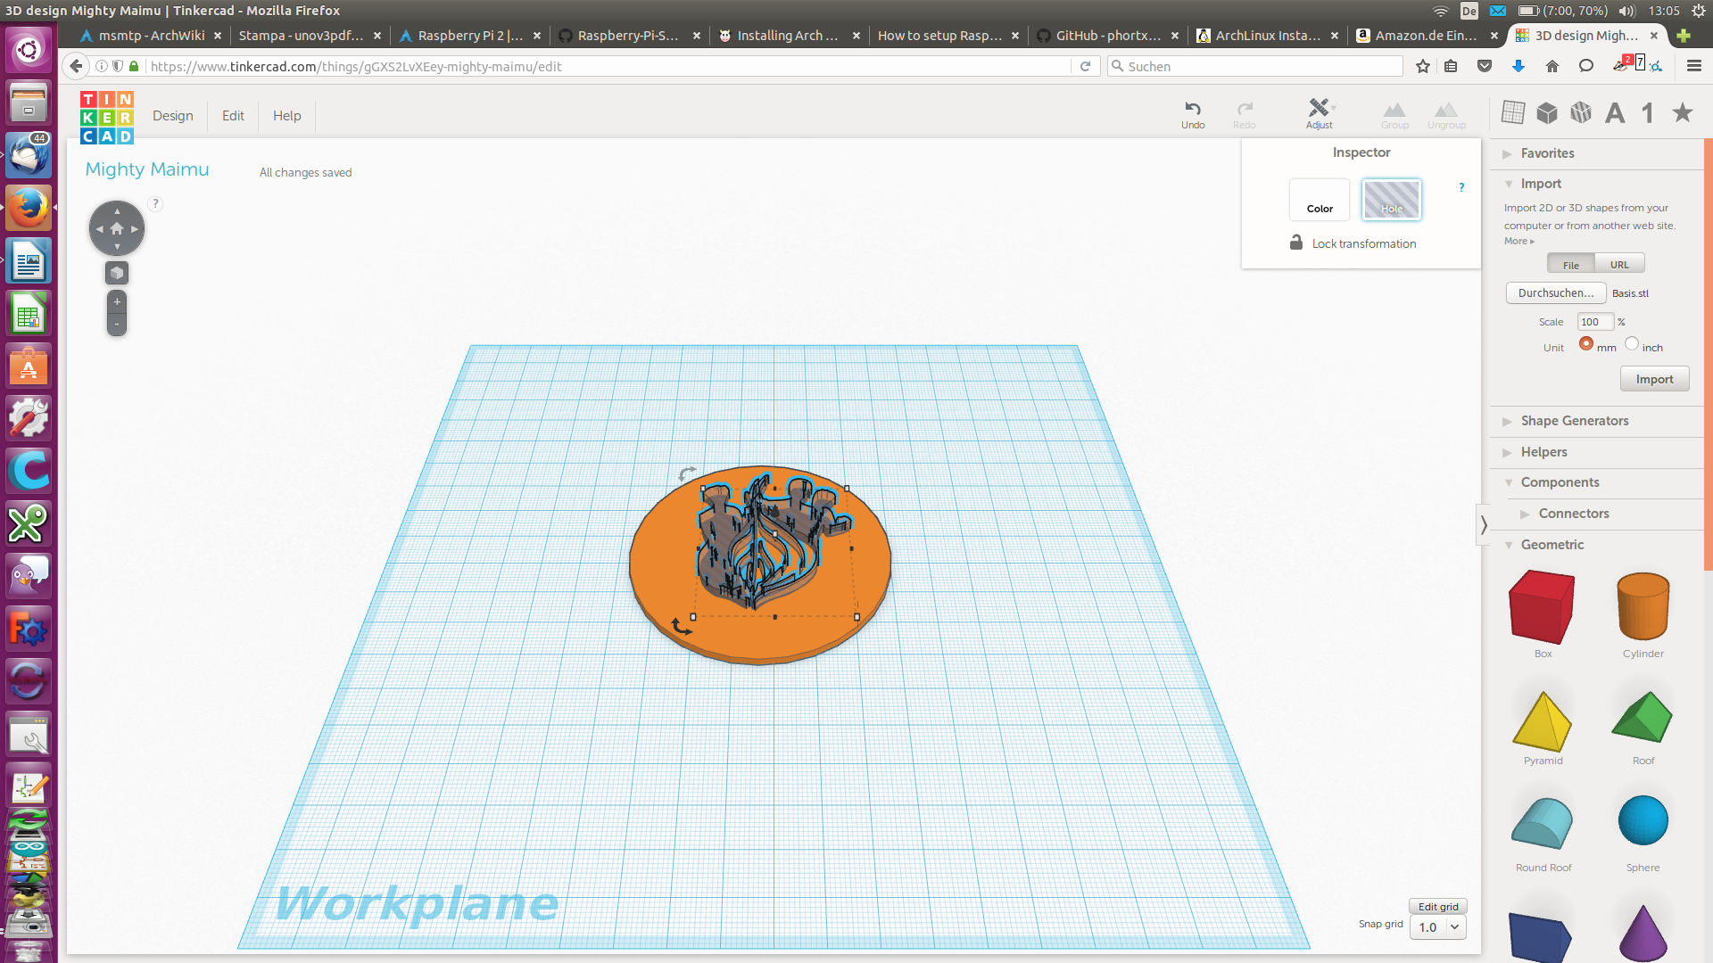 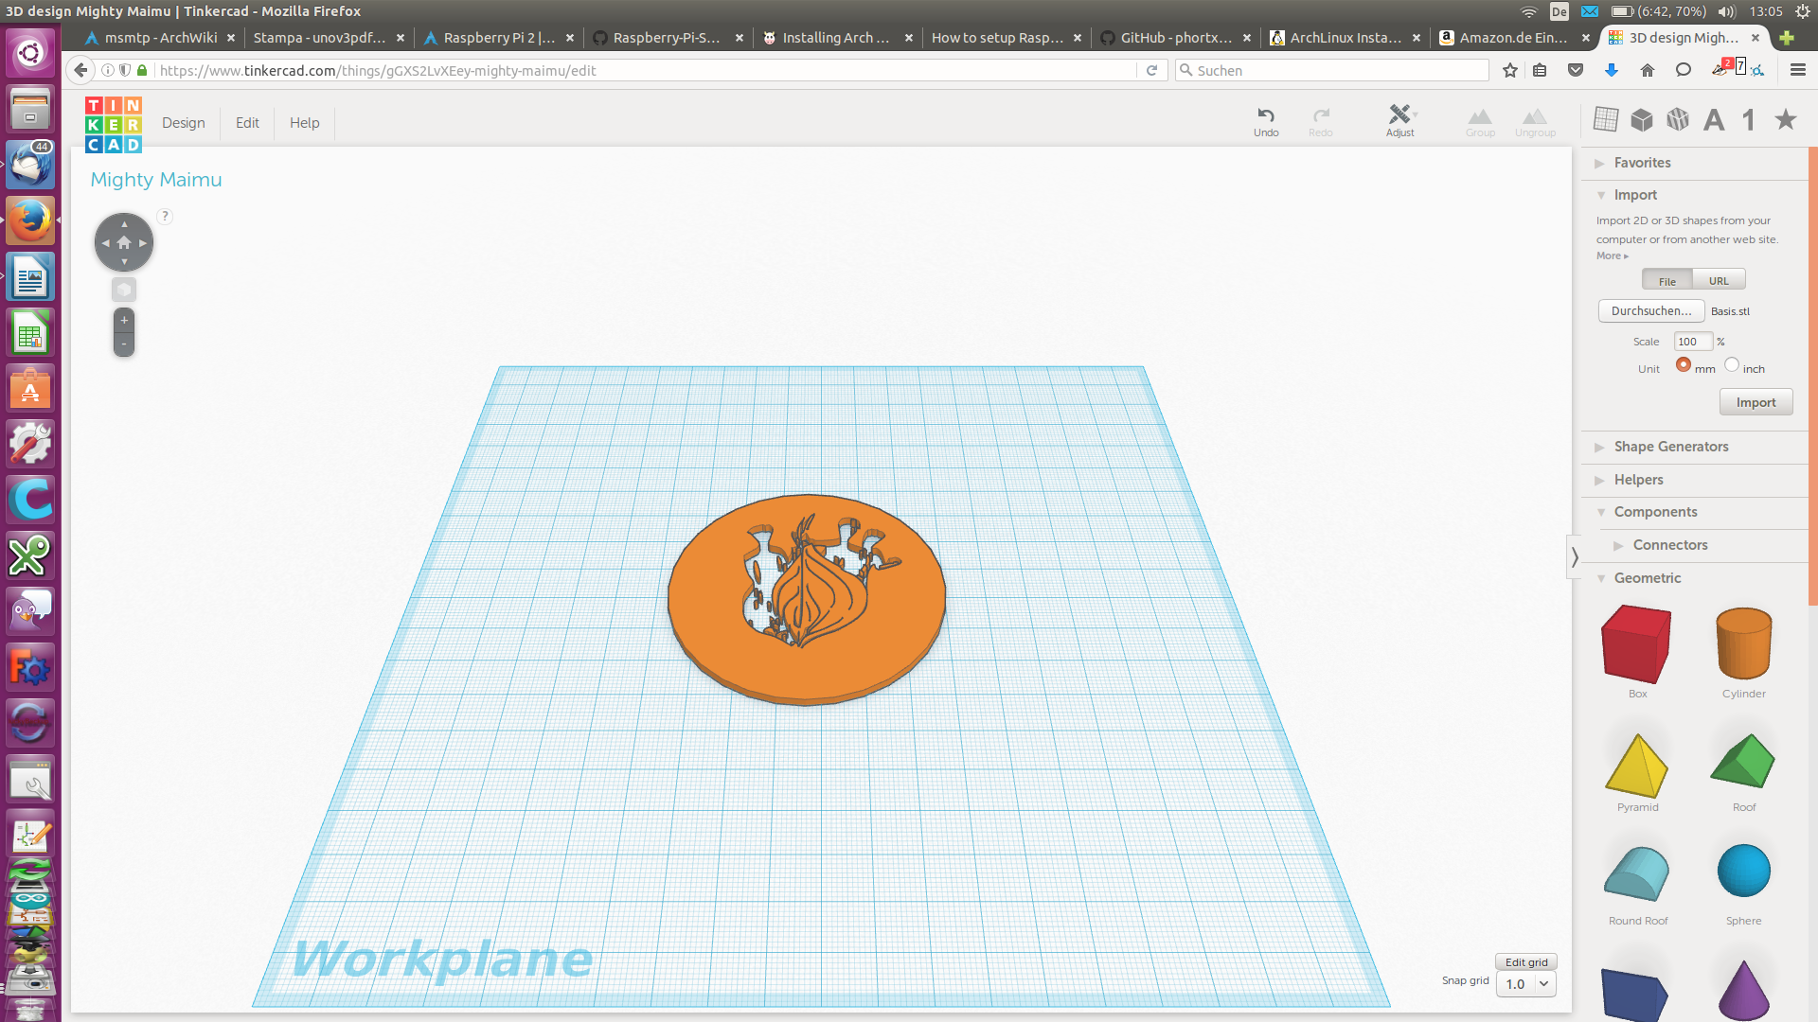
It is as simple as that and you're done with your new STL or if you want, you can edit some more. After all your only limited by your imagination and creativity. Now your ready to print. If you still have some questions, send me an email which you can find here.

Sources
https://wiki.ubuntuusers.de/cp/

