Soldering workshop
The ChaosStuff offers soldering kits, so everyone can evolve his soldering skills. If you need tools, here is the Lendable stuff .

FOSDEM Arduino Kit
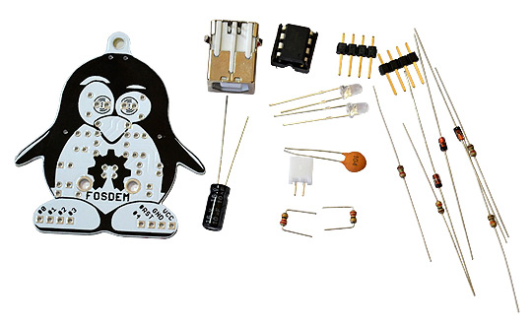
A little Arduino Kit, a tiny but tricky experience.
The board comes in the form of a DIY kit - if you like soldering this is the FOSDEM-85 package suitable for you! FOSDEM-85 is a very tiny - Arduino-inspired board. It is built around the well-known Little wire design and uses micronucleus bootloader. The same design is also used for the Digispark and Adafruit’s Trinket. The microcontroller comes preprogrammed with "micronucleus tiny85" that is suitable for use with the Digispark's Arduino distribution.
- Assembly time: 30min
- cost: 10€
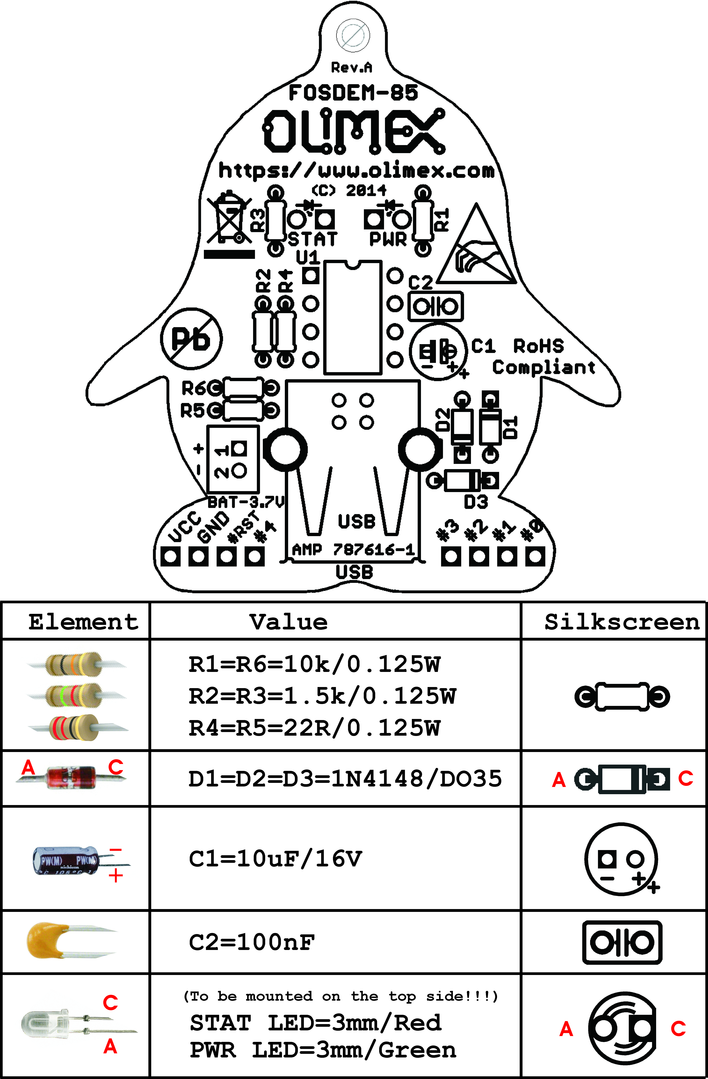

SIMON Kit
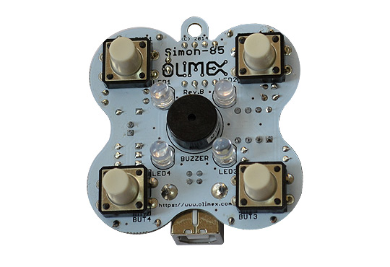
The board is an implementaion of the popular simon game which tests and trains your short-term memory. There are four LEDs and four buttons. The LEDs blink in random pattern which you should repeat with the buttons. Each successful guess increments the amount of blinks. It is built around the well-known Little wire design. The same design is also used for the Digispark and Adafruit’s Trinket. The microcontroller comes preprogrammed with "micronucleus tiny85" that is suitable for use with the Digispark's Arduino distribution.
- Assembly time: 30min
- cost: 10€

Links
[1] FOSDEM Arduino
[2] Simon Kit

