Meshtastic / Meshcore


Name | Meshtastic and Meshcore
Description | Meshtastic is a project that enables you to use inexpensive LoRa radios as a long range off-grid communication platform in areas without existing or reliable communications infrastructure. This project is 100% community driven and open source.
Status | Running
Contact | orimpe
Participants | orimpe
Repository

How it works
Here I document experiences and channel information about the nodes we use in Luxembourg.

Meshtastic
Mestastic utilizes LoRa, a long-range radio protocol, which is widely accessible in most regions without the need for additional licenses or certifications, unlike ham radio operations.
These radios are designed to rebroadcast messages they receive, forming a mesh network. This setup ensures that every group member, including those at the furthest distance, can receive messages.
Additionally, Meshtastic radios can be paired with a single phone, allowing friends and family to send messages directly to your specific radio. It's important to note that each device is capable of supporting a connection from only one user at a time.

Meshtastic C3l Channel
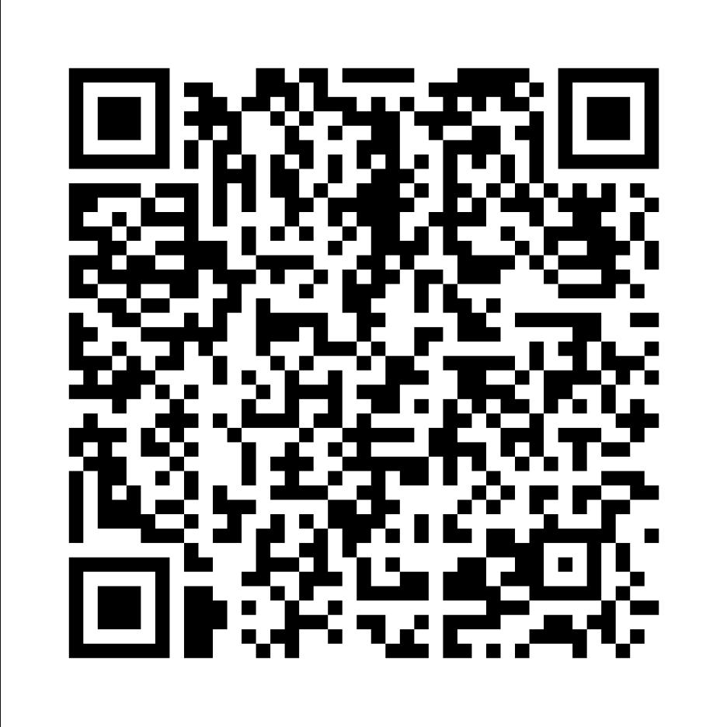
This is our intern Meshtastic Channel. https://meshtastic.org/e/#CgMSAQEKKxIguT-4he7sSztgR8vNdjNHqL2aa1PeTQCl7IcUknvF7dIaB0MzTG1lc2gSCggBOANAA0gBUBs

Meshcore
MeshCore is a multi platform system for enabling secure text based communications utilising LoRa radio hardware. It can be used for Off-Grid Communication, Emergency Response & Disaster Recovery, Outdoor Activities, Tactical Security including law enforcement, private security and also IoT sensor networks. Watch the videos below by one of our founders Andy to learn more!

Meshcore C3L Channels
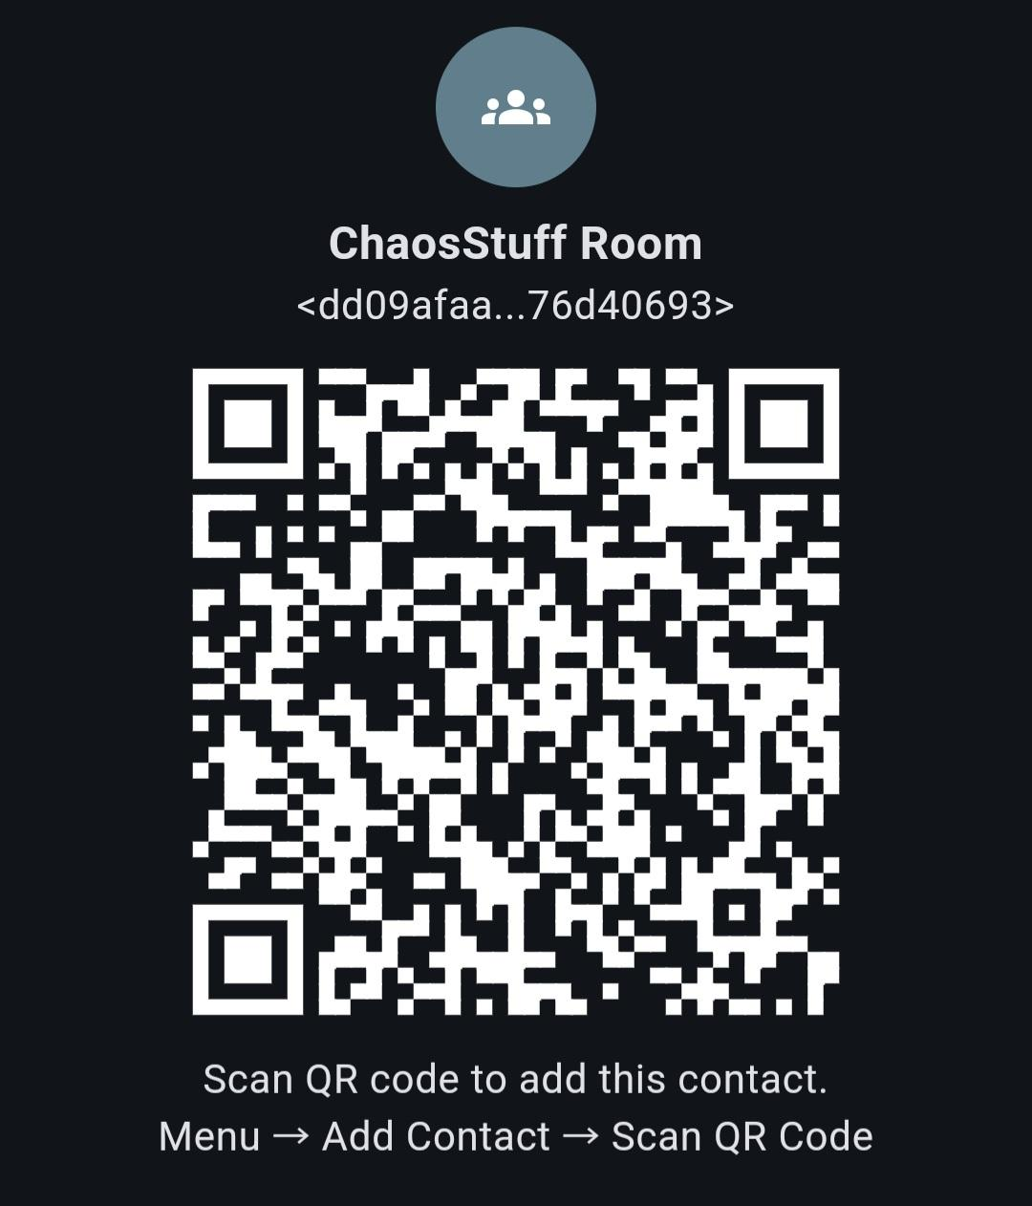
A room server is a simple BBS server for sharing posts. T-Deck devices running MeshCore firmware or a BLE Companion client connected to a smartphone running the MeshCore app can connect to a room server.
Room servers store message history on them and push the stored messages to users. Room servers allow roaming users to come back later and retrieve message history. With channels, messages are either received when it's sent, or not received and missed if the channel user is out of range. Room servers are different and more like email servers where you can come back later and get your emails from your mail server.
A room server can be remotely administered using a T-Deck running the MeshCore firmware with remote administration features unlocked, or from a BLE Companion client connected to a smartphone running the MeshCore app.
When a client logs into a room server, the client will receive the previously 32 unseen messages.

Notes

Seeedstudio T1000-E
- Power ON: Press the button once, wait for 5s until the buzzer sounds. If no response, connect the charging cable to chage the battery.
- Force Reset: Press and hold the button and attach the magnetic charging connector to device for once, then the device will reboot.

Och informativ
- Meshcore Projekt Säit https://meshcore.co.uk
- Meshtastic gudd erklärt vun Meshhessen https://meshhessen.de/
- Meshcore gudd erklärt https://meshcore-de.net/
- Reticulum als Multitalenthttps://reticulum.network/

