Hide & Seek
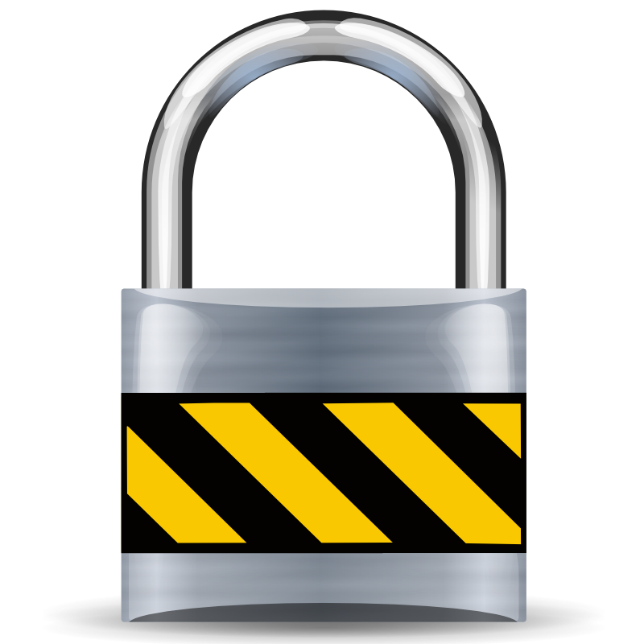
Lots of websites and thus forums, mailing lists and diverse other platforms, provide users with ratings about Proxy / VPN providers. Often, these ratings cannot provide us with the information we need the most. Intel, that hasn't been evaluated by the authors in the way we'd like to see it.
The table below provides you with a quick overview of VPN providers, which have been tested by members of ours. We have selected a few crucial emphases, which appeared non-negotiable for us.
Always check for DNS leaks.
All values which are rated by a number, cannot exceed the value of 5, which is the best one to earn.
Provider | General Rating | Easiness | T&C | OpenVPN | Anonymous Payment | Countries | Price
hide.me | 5 | 5 | 4 | Yes | Yes | Europe, North-America, Africa & Asia | free, plus-4,17€/month, premium-9,17€/month
blackVPN | 5 | 5 |  | Yes | Yes | USA, UK, Canada, Netherlands, Switzerland, Luxembourg, Estonia, Lithuania, Romania, Russia, Ukraine, Panama, Singapore, Australia | 5€-9.50€/month 49€-99€/year
WhatTheServer |  |  |  | Yes | Yes | Netherlands, Sweden, USA | 5/month
cryptostorm |  |  |  | Yes | Yes | Europe, North-America, Asia | free, 3-4 $/month
Mullvad |  |  |  |  | Yes | Netherlands, Germany, Sweden, Canada & USA
ibVPN |  |  |  |  | Yes | 43 different countries
VPNtunnel |  |  |  | Yes |  | Argentina, Australia, Canada, France, Germany, Great Britain, Iceland, Italy, Luxembourg, Netherlands, Panama, Russia, Singapore, Spain, Sweden, Switzerland, Turkey & USA
Anonine |  |  |  | Yes |  | Argentina, Australia, Canada, France, Iceland, Italy, Luxembourg, Netherlands, Panama, Russia, Sweden, Singapore, Spain, Switzerland, Turkey, United Kingdom & USA

