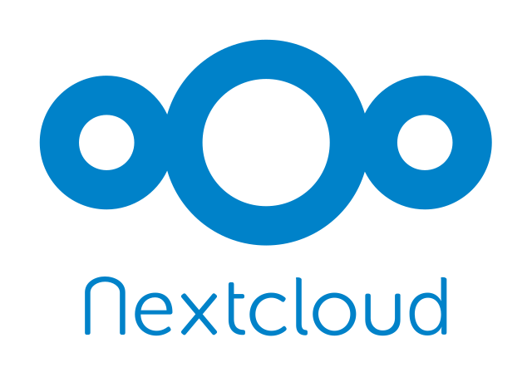

Nextcloud
We run a Nextcloud over at https://cloud.c3l.lu. We use it mainly for our events calendar, polls and video conferences via Nextcloud Talk. Of course it can also be used as a file storage.

How to get an account?
As a member you can get an account. Ask your friendly NOC for an account.
Video conferences with a larger audience is now possible thanks to our own signaling server

