33C3 - works for me
The Chaos Communication Congress is the annual symposium and hacker party of the Chaos Computer Club (CCC). During four days between Christmas and New Years Eve, thousands of hackers, technology freaks, artists and utopians get together in Hamburg to communicate, learn from each other, and party together. We focus on topics such as information technology, digital security, making and breaking. We engage in creative, sceptical discourse on the interaction between technology and society.

"works for me"
A commonly used phrase by software developers to indicate that the bug reported by a user is not repeatable on their machine, and will therefore receive no more attention. Usually connotes a dismissive approach, where anything that is not visible immediately to the developer is „someone else’s problem“ and is therefore not worth fixing.
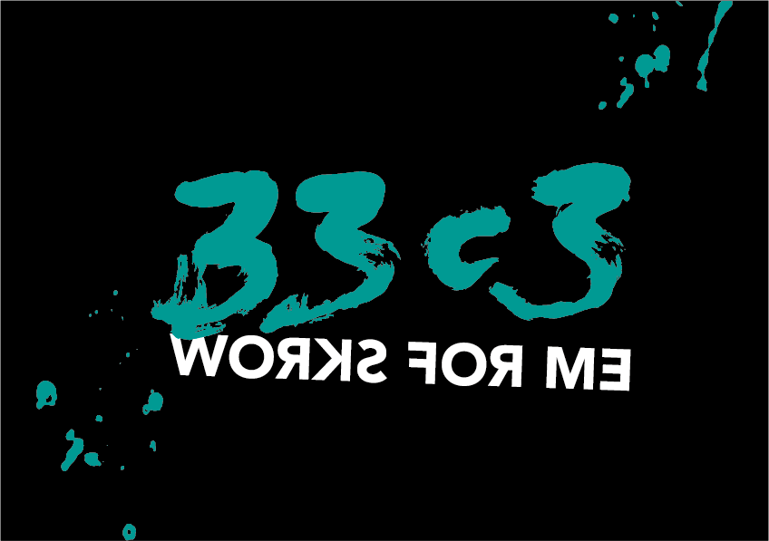

Vouchers
metalgamer
ALL GONE!

Congress Everywhere
We host this event as well. Details can be found here.

