Hack.lu 2017
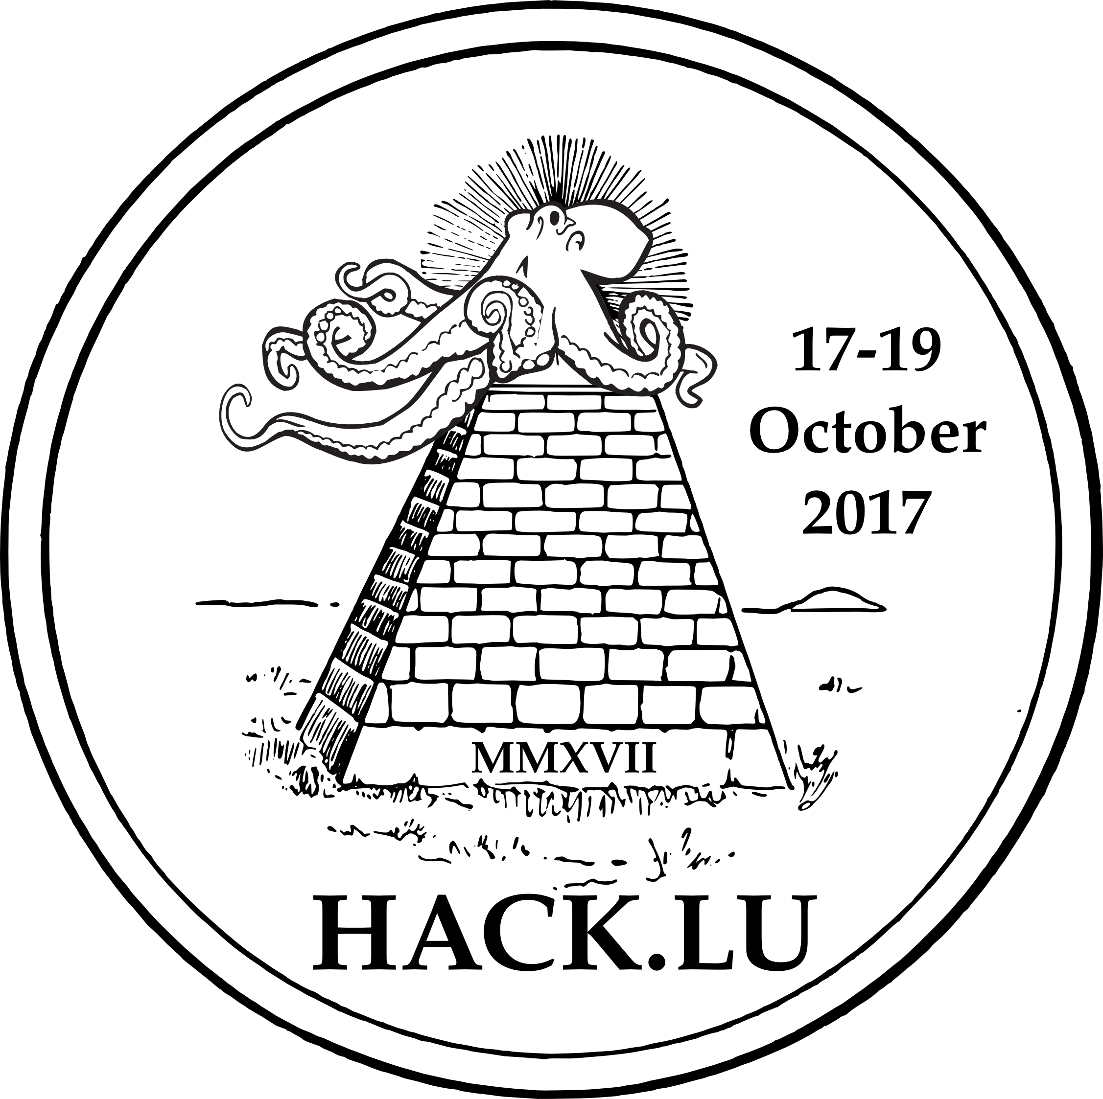
Date | 17/10/2017 - 19/10/2017
Time | 08:45 (local time)
Venue | Parc Hotel
Description | Hack.lu is an open convention/conference where people can discuss about computer security, privacy, information technology and its cultural/technical implication on society. It's the 13th edition (17-19 October 2017) of hack.lu in Luxembourg.
Website | https://2017.hack.lu
Contact | fantawams
Participants | metalgamer fantawams
Books:
Book | Price
The Black Box Society | 25€
Spam Nation | 20€
For the Win | 15€
Beautiful Trouble | 30€
The Cuckoos Egg | 20€
Ghost in the Wires | 15€
Machine Learning | 20€
Weapons of Math Destruction | 15€
Homeland | 20€

