Social Event #0 - Spark-Up: The S in IoT stands for security!
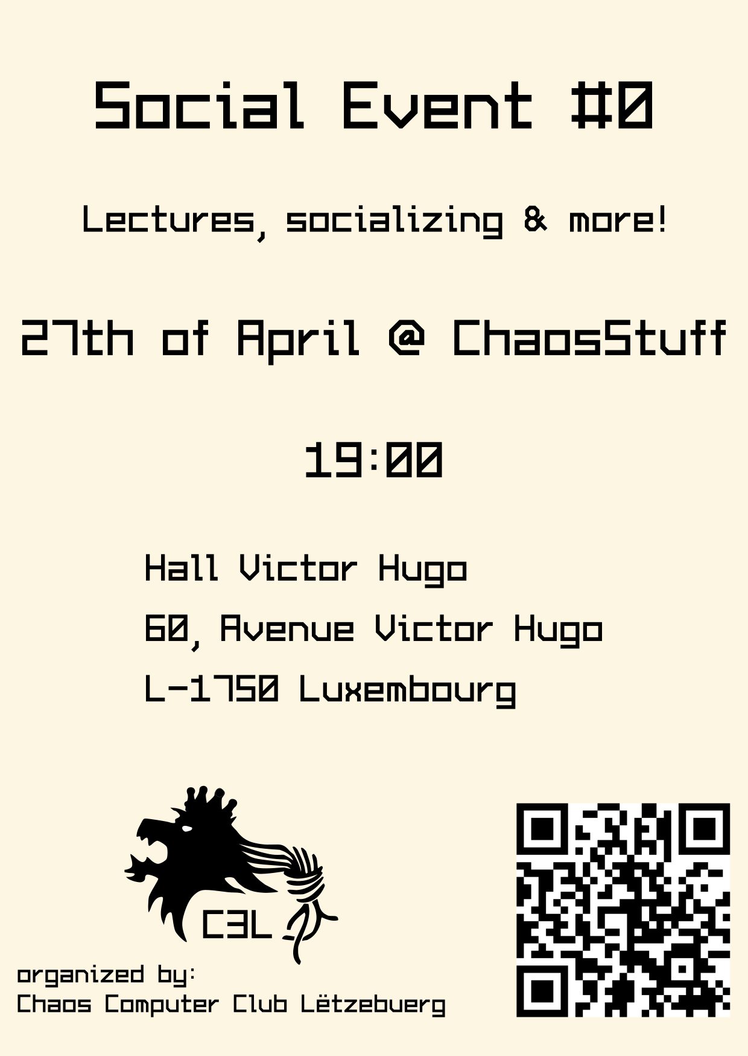
Date | 27/04/2019 - 19:00
Venue | ChaosStuff
Description | Lectures, socializing & more!
Contact | metalgamer
Participants | deflenken, orimpe, fantawams, staybehind
Our first social event. Come and socialize with other like-minded people and listen to talks.

Talks
The talks will start at around 20:00.
Topic | Language | Speaker | Slides | Recording
Introduction to MQTT: A machine-to-machine connectivity protocol | LB | metalgamer | PDF | Youtube
Introducing KiCad: Creating PCBs as easy as it gets | LB/EN/DE | fantawams | N/A | N/A
Technical standards for IoT (and standardization in Luxembourg) | LB/EN/DE | staybehind | N/A | N/A

Aftermath
There will be Tschunk.

Videos

