rc3: Remote Chaos Experience
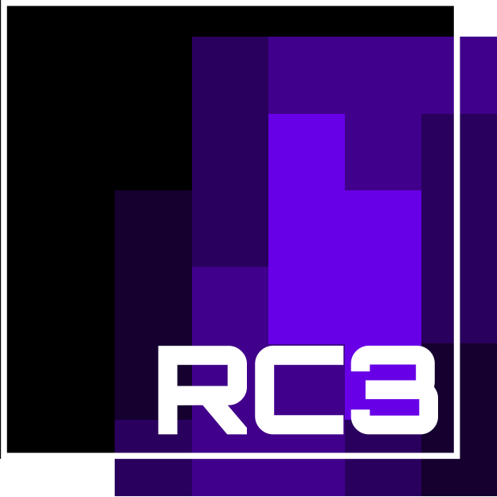
Date | 27/12/2020 - 30/12/2020
Venue
Description
Website | Blog Fahrplan
Contact | metalgamer
Participants


