German Version

World Wide Open Hackerspace Day
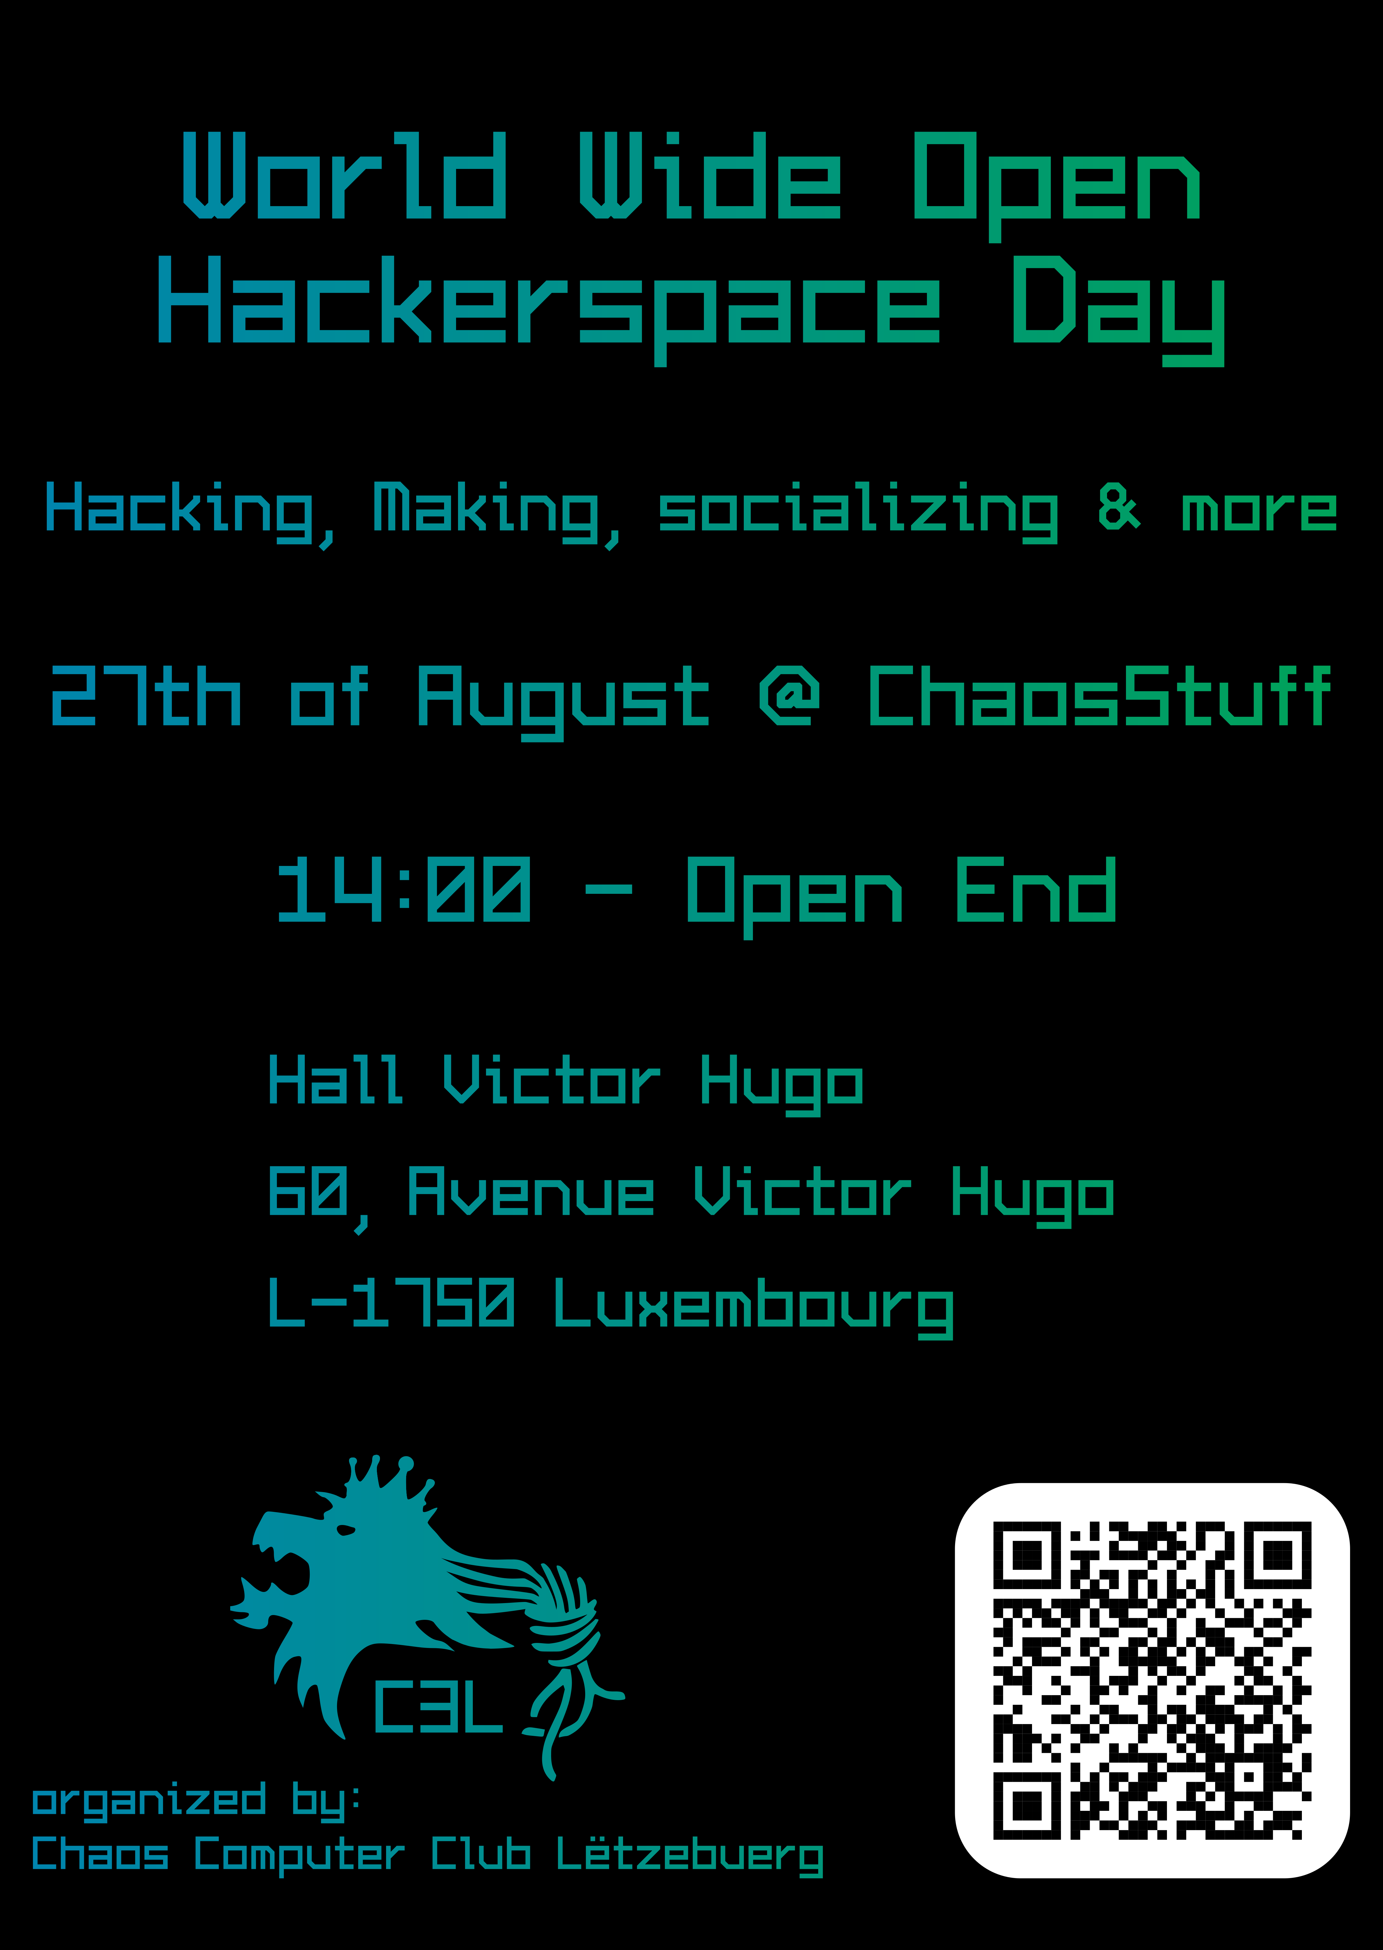
Date | 27/08/2022 - 14:00
Venue | ChaosStuff
Description
Website
Contact | metalgamer
Participants

