Donations
A club can only live with members and money. C3L is no exception. Right now we have members but we lack the money to finish or even create new projects. As a club we know that if you want to attract new donations you need to provide the donor something in return. It must be visible what your donated money is used for. That's why we are now putting a donation bar on every project Wiki page. This indicates what project needs money and how much.
A simple overview of fund-able projects has now been created. So if you want to help us finishing projects or to kick-start new ones then please go ahead. Check out our current projects and decide by yourself what you want to actively support. No project found that you are interested in? Join us and launch it by yourself!


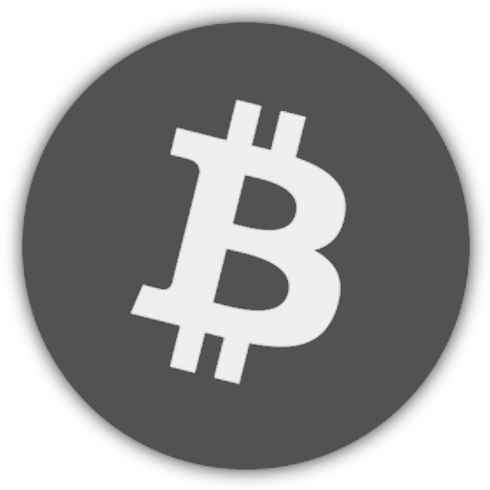

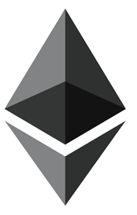
We accept Bitcoin, Ether, Monero, cash via mail and of course wire transfers!

Projects
Here's a list of projects that currently seek funding:
- YAB - Yet another Bar
- Frënn vun der Ënn - Tor Exit Node Hosting
- Freifunk - Public WiFi done right!
- Ultimaker 3
- CNC-mill

Bank Details
Account-Holder: Chaos Computer Club Lëtzebuerg
BIC/Swift: BCEELULLXXX
IBAN: LU29 0019 2855 3890 4000
Communication: Donation $PROJECTNAME

Bitcoin
BTC address: 3BV5UPToMUmXJiqUVndHjSSq2HqDW8npRd


Ethereum
iban: XE5839U7TWQG0YJ0WWFPKV2UMDEZ249SFH1
hex: 0x1C05b4C236914B218B57e0E25948d416B4885655


Monero
Monero address: 44e5Zx1XSkPQYfk8wjDNVM4ErZczbAwsBQjYMzJPjZTKHN7wPbLNVuUNAyXzftjokhGpgTWbETpNNZsCqybFcrKhHBZB5eR

Of course you can also donate without specifying a certain project!

Webshop
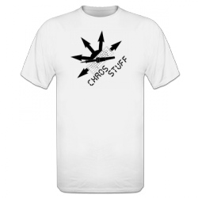
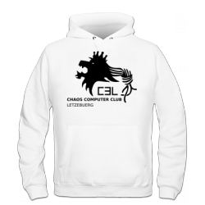
Spread the word by wearing one of our Club shirts. You can order on our outsourced online shop. Easy payments, fast delivery and good quality.
Should you want to buy the stuff with Bitcoin then you should use a service like Bitwala.

Membership
See the Membership page.

