2021

Overview
Overview
 | 2020 | 2021
Saldo | 1094,58€ | 525,01€
 | Difference | -569,57€

Income
Income
Donations | 2462,63€
Membershipfee | 1560,00€
Food and Drinks | 489,00€
 | TOTAL | 4511,63€

Expenses
Expenses
Administration | 2030,10€
IT | 1695,20€
Infrastructure | 1276,65€
Food and Drinks | 79,25€
 | TOTAL | 5081,20€

2020

Overview
Overview
 | 2019 | 2020
Saldo | 1542,61€ | 1094,58€
 | Difference | -448,03€

Income
Income
Donations | 2724,21€
Membershipfee | 1441,00€
Food and Drinks | 3216,76€
 | TOTAL | 7381,97€

Expenses
Expenses
Administration | 871,12€
IT | 2521,00€
Infrastructure | 2548,66€
Food and Drinks | 1889,22€
 | TOTAL | 7830,00€

2019

Overview
Overview
 | 2018 | 2019
Saldo | 446,52€ | 1542,61€
 | Difference | +1096,09€

Income
Income
Donations | 2218,04€
Membershipfee | 1400,00€
Food and Drinks | 3791,67€
 | TOTAL | 7409,71€

Expenses
Expenses
Administration | 917,65€
IT | 2023,57€
Infrastructure | 1765,83€
Food and Drinks | 1606,57€
 | TOTAL | 6313,62€

2018

Overview
Overview
 | 2017 | 2018
Saldo | 829,04€ | 446,52€
 | Difference | -382,52€

Income
Income
Donations | 1588,43€
Membershipfee | 1026,00€
Food and Drinks | 3911,71€
 | TOTAL | 6526,14€

Expenses
Expenses
Administration | 105,97€
IT | 4230,85€
Infrastructure | 995,95€
Food and Drinks | 1575,89€
 | TOTAL | 6908,66€

2017

Overview
Overview
 | 2016 | 2017
Saldo | 2089,78€ | 829,04€
 | Difference | -1260,74€

Income
Income
Donations | 1974,06€
Membershipfee | 1075,00€
Food and Drinks | 2301,00€
 | TOTAL | 5350,06€

Expenses
Expenses
Administration | 926,07€
IT | 2487,38€
Infrastructure | 1610,31€
Food and Drinks | 1587,04€
 | TOTAL | 6610,80€

2016

Overview
Overview
 | 2015 | 2016
Saldo | 580,82€ | 2089,78€
 | Difference | +1508,96€

Income
Income
Donations | 2543,18€
Membershipfee | 1245,00€
Food and Drinks | 5365,48€
 | TOTAL | 9153,66€

Expenses
Expenses
Administration | 896,28€
IT | 1581,89€
Infrastructure | 2062,10€
Food and Drinks | 3104,43€
 | TOTAL | 7644,70€

BTC
BTC
 | 2015 | 2016
Saldo | 291.04 mBTC | 393.88 mBTC
 | Difference | +102.84 mBTC

2015
Saldo begin 2015: 297,50€
Saldo end 2015: 580,82€
Donations received: 9,52€

Biggest expenses
Storage rental fees for a year: 2.490,00€
Server payments sum up to: 0€ - Server donated by Visual Online

Biggest Income
Server farm management for a third party: 2.280,00€

BTC
Saldo begin 2015: 0,00000000 BTC
Saldo end 2015: 0,29104273 BTC
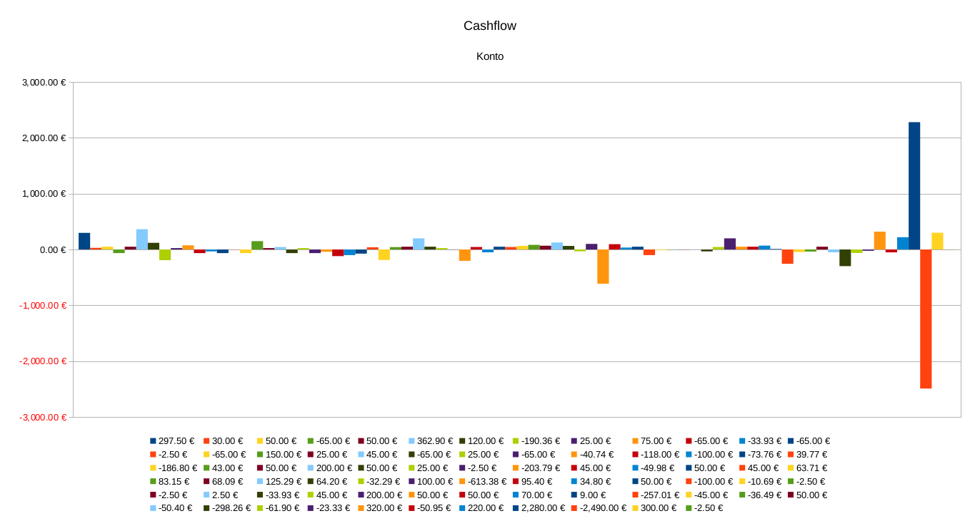

2014
Saldo begin 2014: 17,36€
Saldo end 2014: 297,50€
Donations received: 534,50€

Biggest expenses
Radio show payment for a year: 420,00€
Server payments sum up to: 561,65€

Biggest Income
Hack.lu income from our booth: 200€
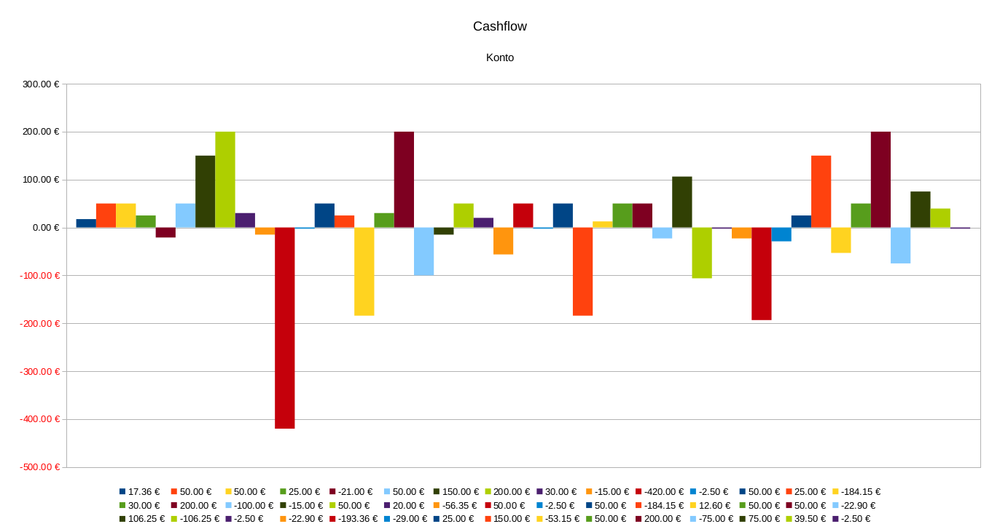

2013
Saldo begin 2013: 356,41€
Saldo end 2013: 17,36€
Donations received: 584,12€

Biggest expenses
Server payment for a year: 430,42€
Stuff for the Freedom Not Fear Demo: 437,30€
Ultimaker: 1697,63€

Biggest Income
Escher Commune payment for workshops: 1706,02€


