History
Funded in 1981, the Chaos Computer Club did not only invade Hamburg and Berlin with its strong idealistic views on hacktivism or network politics, but reached far over the national borders. It was, and still is, an inspiration to many people in the world. Thus, also the reason for funding its own local 'branch' in Luxembourg.
Frederik Fischer, a journalist with Krautreporter, is dedicating several pages to the founding moments & elements of the club. As the articles are published, will we be posting them below:
- Die Geschichte des Chaos Computer Clubs: Datendämmerung
- Tuwat.txt - die Geschichte des Chaos Computer Clubs

Timeline
Date | Event
23th May 2008 | Official Founding Date
? | 'Tango Hack'
? | Less than 3 registered members
11th June 2015 | Key delivery of very own first hackerspace
? October 2015 | Official Inauguration of ChaosStuff

Impressions

2011

Ubuntu Release 11.04 Release Party
gallery>:organization:history

2009
<imgcaption label|ChaosMeeting 15.09.2009 @ syn2cat Hackerspace, Stroossen>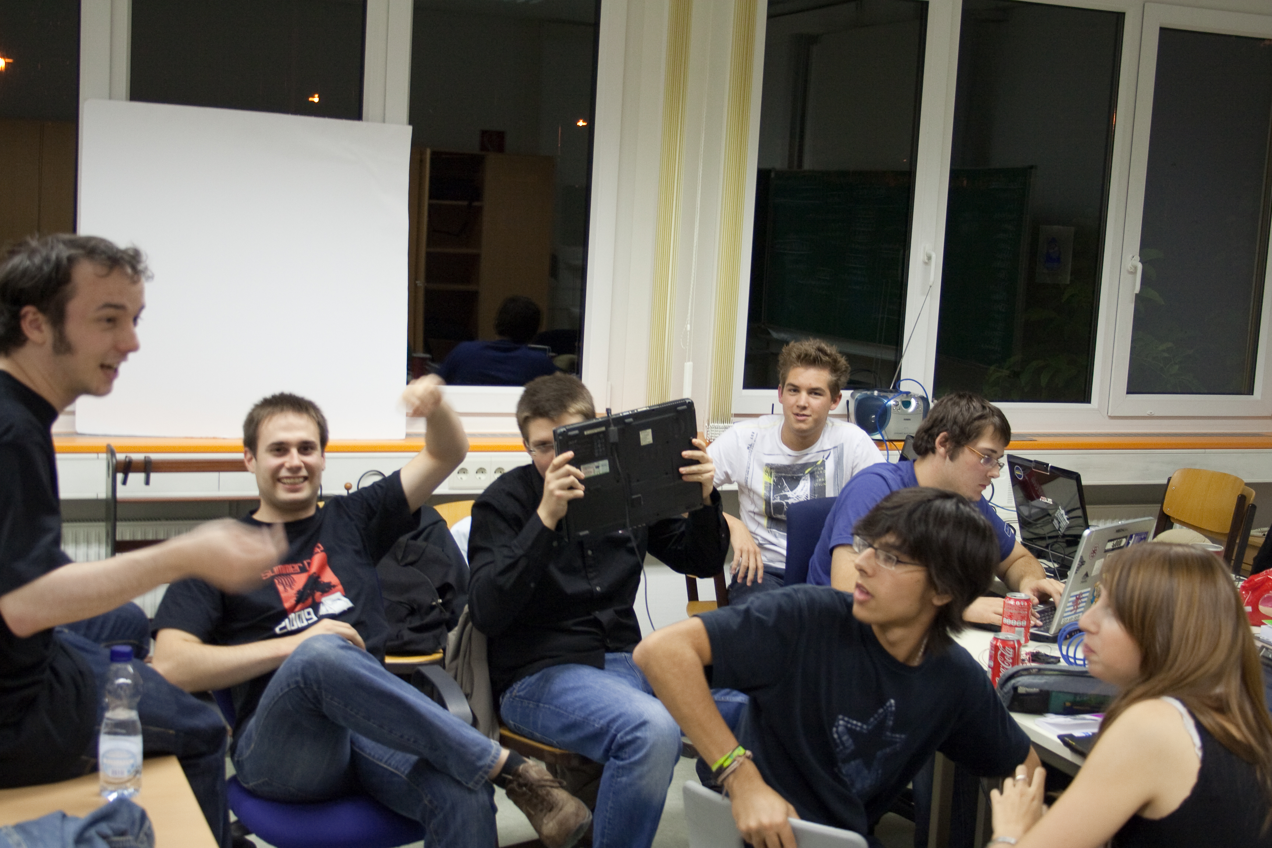</imgcaption> <imgcaption label|ChaosMeeting 15.09.2009 @ syn2cat Hackerspace, Stroossen>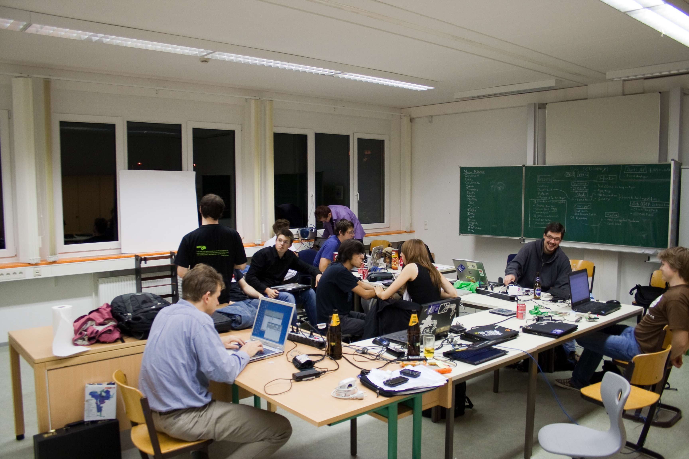</imgcaption>
Copyright Notice:
Some of the pictures have been copied from [[https://wiki.hackerspace.lu/]

